DO NOT DISTRIBUTE BEYOND PSPAP WORKSHOP PARTICIPANTS AT MRNRC

|  |  |  |  |  |
| --- | --- | --- | --- | --- |
| ERDC/EL TR-16-DRAFT |  |  | ERDC-CastleLogo1 | |
|  |  | Draft Version 6  Science and Adaptive Management Plan  Missouri River Recovery Program  Excerpts of material relevant to pallid sturgeon PSPAP workshop | |
|  |  |  | Draft/Pre-decisional/For Review and Comment | December 2016 |
|  |  |  | |
| Draft Document for Review | |
|  |  |

ERDC/EL TR-XX-DRAFT

December 2016

Draft Version 6

Science and Adaptive Management Plan - excerpts

Missouri River Recovery Program

J. Craig Fischenich

Environmental Laboratory  
U.S. Army Engineer Research and Development Center  
3909 Halls Ferry Rd  
Vicksburg, MS 39180

Kate E. Buenau

Marine Science Laboratory

Pacific Northwest National Laboratory

U.S. Department of Energy  
1529 W. Sequim Bay Rd  
Sequim, WA 98382

Joseph L. Bonneau and Craig A. Fleming

U.S. Army Corps of Engineers

Omaha District  
Gavins Point Project Office

Yankton, SD 57078

David R. Marmorek, Marc A. Nelitz,   
Carol L. Murray and Brian O. Ma

*ESSA*

*600 – 2695 Granville Street  
Vancouver, BC Canada V6H 3H4*

Graham Long

*Compass Resource Management Ltd  
210 - 111 Water Street  
Vancouver, BC Canada V6B 1A7*

Carl J. Schwarz

Department of Statistics and Actuarial Science,

Simon Fraser University

8888 University Drive  
Burnaby, BC Canada V5A 1S6

Draft Report/Pre-decisional/For Review and Comment

Submitted as an interim product for review only

Prepared for U.S. Army Corps of Engineers  
Washington, DC 20314-1000

Under Missouri River Recovery Program

**Abstract:** The Missouri River Recovery Program (MRRP) is undergoing a transformation resulting from 2011 recommendations by an Independent Science Advisory Panel and the Missouri River Recovery Implementation Committee (MRRIC). An Effects Analysis study established the best available scientific information and provided the foundation for an Adaptive Management Plan (AM Plan) that addresses lingering uncertainties and improves management decisions while implementing actions that avoid jeopardizing the three federally listed species in the system. This draft AM Plan includes a process for resolving critical uncertainties using a framework consisting of four implementation levels: 1) research, 2) in-river testing of hypotheses, 3) scaled implementation of select management actions, and 4) full implementation. The decision criteria for moving to higher levels of implementation are included. A NEPA evaluation of alternative management actions identified an initial suite of actions that will be implemented to meet the objectives of the MRRP. This Draft AM Plan accompanies the Draft Missouri River Recovery Management Plan-Environmental Impact Statement and provides the roadmap for the implementation of the selected alternative and for the identification of subsequent management needs should the initial suite of actions fail to meet objectives. The AM Plan will be implemented collaboratively by the U.S. Army Corps of Engineers, the U.S. Fish and Wildlife Service, and MRRIC following the governance process outlined in the AM Plan.

**DISCLAIMER:** The contents of this report are not to be used for advertising, publication, or promotional purposes. Citation of trade names does not constitute an official endorsement or approval of the use of such commercial products. All product names and trademarks cited are the property of their respective owners. The findings of this report are not to be construed as an official Department of the Army position unless so designated by other authorized documents. This is a draft document and is subject to change.

**DESTROY THIS REPORT WHEN NO LONGER NEEDED. DO NOT RETURN IT TO THE ORIGINATOR.**

Table of Contents

List of Figures and Tables xi

Preface xix

Unit Conversion Factors xxi

1 Introduction 1

1.1 Overview, background and context 1

1.1.1 Overview 1

1.1.2 Missouri River Recovery Program (MRRP) 1

1.1.3 Purpose and scope of the MRRP 7

1.1.4 Effects Analysis (EA) and modeling framework for the MRRP 8

1.1.5 AM and decision-making concepts 11

1.1.6 Relationship between MRRMP-EIS alternatives and actions in the AM Plan 12

1.2 Adaptive Management (AM) governance 15

1.2.1 AM decision needs 15

1.2.2 Program composition, roles, and responsibilities 17

1.2.3 AM decision process 19

1.2.4 Protocols and procedures 22

1.2.5 Other key points and issues 22

1.3 AM for plovers and terns 22

1.3.1 Bird objectives, uncertainties, and targets 23

1.3.2 Implementing, monitoring, and evaluating bird actions 26

1.3.3 Decisions and planning contingencies 30

1.3.4 Other key points or issues 32

1.4 AM for pallid sturgeon 32

1.4.1 Overview of Chapter 4 33

1.4.2 Pallid sturgeon objectives and key uncertainties 33

1.4.3 Pallid sturgeon framework 36

1.4.4 Pallid sturgeon in the Upper Missouri River 37

1.4.5 Pallid sturgeon in the Lower Missouri River 40

1.5 Human Considerations (HC) 43

1.5.1 How HCs are considered 44

1.5.2 Monitoring and assessment of HCs 44

1.5.3 Further considerations 45

1.6 Data acquisition, management, reporting and communications 45

1.6.1 Monitoring and other data acquisition issues 46

1.6.2 Data management 46

1.6.3 Reporting and communications 47

1.6.4 Quality assurance (QA) and quality control (QC) 48

1.7 Summary 48

2 **Governance of the AM Program** 52

2.1 Definition, principles and key attributes for effective governance 52

2.1.1 Governance defined 52

2.1.2 Attributes of governance that enable AM 52

2.1.3 Ensuring objective and reliable science in the Missouri River Recovery Program 55

2.2 Decision needs for adaptively managing the MRRP 57

2.2.1 Scope of decisions in the MRRP 58

2.2.2 Balancing needs for the birds and fish 61

2.2.3 Timing of AM decisions 62

2.2.4 Role of decision criteria in the MRRP 65

2.2.5 NEPA, the Master Manual, and decisions regarding management actions 66

2.3 AM program composition, roles, and responsibilities 67

2.3.1 Oversight level 72

2.3.2 Management Team 74

2.3.3 Implementation-Level Teams 77

2.3.4 Technical Team 82

2.3.5 Integrated Science Program (ISP) 84

2.3.6 Other MRRP entities and position descriptions 86

2.3.7 Overview of MRRIC roles and responsibilities 90

2.3.8 Basin states, other Federal agencies, and tribal roles outside the MRRIC collaborative process 101

2.4 AM Decision process, critical engagements, and workflows 104

2.4.1 Overview of the MRRP AM decision process 104

2.4.2 Basic Annual AM engagement process 105

2.4.3 Science Update process 109

2.4.4 WP development and approval 116

2.4.5 Consideration of new management actions 119

2.4.6 Workflows for specific scenarios 123

2.5 Important protocols and procedures 143

2.5.1 Procedures for dispute resolution 144

2.5.2 Procedures for changing the governance of the MRRP AM Program 146

2.5.3 Procedures for adjusting objectives, targets, or decision criteria. 147

2.5.4 Procedure for addressing significant new information 148

2.5.5 Procedures for elevating and relegating hypotheses 150

2.5.6 Independent external review 151

2.5.7 Requirements for research and focused study efforts 153

2.5.8 Agendas for the Fall Science Meeting and for the Annual AM Workshop 154

2.5.9 Guidelines for technical publications 154

2.5.10 Example Fact Sheet 155

2.5.11 Cultural Resource Plan 155

2.5.12 Program priorities development process 155

2.5.13 Cost management 156

2.5.14 Program safety and health requirements 159

3 Adaptive Management for Plovers and Terns 160

3.1 Assess 160

3.1.1 Management objectives and scope for least terns and piping plovers 160

3.1.2 Key findings from Effects Analysis (EA) 164

3.2 Plan and Design 175

3.2.1 Bird Framework 175

3.2.2 Metrics and management conditions 179

3.2.3 Targets 184

3.2.4 Management Actions 190

3.2.5 Effects of Pallid Sturgeon Actions on Terns and Plovers 220

3.3 Monitoring 223

3.3.1 Monitoring of hydrology and habitat metrics 224

3.3.2 Existing program for monitoring of population metrics and associated challenges 225

3.3.3 Options for changing the population monitoring program 227

3.3.4 Additional species monitoring 231

3.3.5 Action effectiveness monitoring and research 231

3.3.6 Events requiring additional monitoring 232

3.3.7 Monitoring and research to improve models and action planning/design 233

3.4 Implementation 234

3.5 Evaluation 234

3.5.1 Evaluation of habitat status relative to targets 235

3.5.2 Evaluation of population status relative to targets and objectives 241

3.5.3 Overall Evaluation of Status and Management Needs 244

3.5.4 Evaluation of management conditions 248

3.5.5 Incorporation of new information 249

3.5.6 Evaluation of key relationships and science questions 250

3.5.7 Evaluation of action effectiveness 251

3.5.8 Evaluation of cross-program effects 252

3.5.9 Model updates and validation 253

3.5.10 Ancillary information 255

3.5.11 Unexpected outcomes 256

3.6 Decisions and planning contingencies 257

3.6.1 Decision making process 258

3.6.2 Information for making decisions 259

3.6.3 Management action decisions 260

3.6.4 Decisions related to experiments and research activities 266

3.6.5 Decision criteria for when targets are not met 267

3.6.6 Decisions to add, change, or remove management actions 272

3.6.7 Decisions to change metrics and targets 273

4 Adaptive Management of Pallid Sturgeon in the Missouri River 276

4.1 Assess 277

4.1.1 Goals and management objectives for pallid sturgeon 277

4.1.2 Key findings from Effects Analysis and more recent work 282

4.2 Plan and Design 303

4.2.1 Pallid sturgeon framework 303

4.2.2 Tradeoffs between different learning strategies 312

4.2.3 Recommended learning strategy for AM Plan 313

4.2.4 Overview of Level 1 and 2 Components and Decision Criteria 313

4.2.5 Details on Level 3 Actions (and associated Level 2 Components) for Upper Missouri River 325

4.2.6 Details on Level 3 Actions (and associated Level 2 components) for Lower Missouri River 353

4.3 Implement 405

4.3.1 Implementation Plan 405

4.4 Monitor 411

4.5 Evaluate 413

4.5.1 Evaluation Methods 413

4.6 Decide 416

5 Human Considerations 420

5.1 Background 420

5.2 Assessing Human Considerations 422

5.2.1 Objectives 422

5.2.2 How HCs are considered in operational decision making 422

5.2.3 Assessment of effects of actions under the MRRMP 425

5.3 Plan and Design 429

5.3.1 Management actions considered in the MRRMP-EIS 429

5.3.2 How HCs are considered in site-specific planning and design of actions under the preferred alternative 431

5.3.3 How HCs are considered in planning and design of actions outside the preferred alternative 432

5.4 Implementing the MRRP 433

5.5 Monitoring for Human Considerations 434

5.5.1 Introduction 434

5.5.2 Reducing uncertainties through monitoring 441

5.5.3 Screening to identify higher priority monitoring studies. 445

5.5.4 Monitoring of HCs under the MRRP Preferred Alternative 448

5.5.5 Monitoring considerations for potential future management actions 455

5.6 Evaluating Effects of Actions on HCs 467

5.6.1 Evaluation of Human Considerations in an annual cycle 467

5.6.2 Model updating and validation analyses 472

5.6.3 Trade-off analyses to support Work Plan development 472

5.6.4 Incorporation of new information 472

5.6.5 Ancillary information 473

5.7 Decisions under AM 473

5.7.1 Decision making process 473

5.7.2 Decisions regarding monitoring and assessment for HCs 474

5.7.3 Decisions regarding the implementation of the preferred alternative 475

5.7.4 Decisions regarding the implementation of new actions outside the preferred alternative 476

5.8 Potential Alternative Definition Modifications Intended to Reduce Impacts to HCs 479

5.8.1 Context 479

5.8.2 Methodology for identifying the proposed modifications 480

5.8.3 Possible Alternative Definition Modifications Intended to Reduce Impacts to HCs 481

6 Data Acquisition, Management, Reporting and Communications 491

6.1 Principles and practices underpinning monitoring and evaluation, data management, and effective communications 491

6.1.2 Issues of scale 496

6.1.3 Actionable science 497

6.2 Monitoring and data acquisition 498

6.2.1 Pallid sturgeon monitoring data acquisition and analysis approach 499

6.2.2 Bird monitoring data acquisition and analysis approach 500

6.2.3 System status and HC data acquisition and analysis 501

6.2.4 Research data acquisition 502

6.2.5 New Information 503

6.3 Data and Information Management 503

6.3.1 Overview 503

6.3.2 Purpose and Objectives 506

6.3.3 Reporting and communication 509

6.3.4 Proposed work plan for developing the Data Management System (DMS) 513

6.3.5 DMS Structure and Functionality 518

6.3.6 Integrating Existing Data Management Systems 524

6.3.7 Responding to existing and emerging information needs 529

6.4 Quality assurance and quality control 530

6.4.1 Basic Principles for Quality Assurance 531

6.4.2 Data Quality Objectives (DQOs) 533

6.4.3 QAPP organization and content 533

6.4.4 QAPP implementation responsibilities 534

6.4.5 Alternative Procedures or Variances 535

References Cited 536

Appendices relevant to PSPAP (separate document) 547

Appendix D. Population Monitoring and Modeling for Pallid Sturgeon 552

Appendix E. Listing and Description of Protocols for Sturgeon-Based Process Monitoring and Assessment 553

Appendix K. Pallid Sturgeon Metrics 560

# Introduction

**Note:** This is a draft document and is subject to change. Further revision will occur in conjunction with the Draft MRRMP-EIS.

## Overview, background and context < section removed >

## Adaptive Management (AM) governance < section removed >

## AM for plovers and terns < section removed >

## AM for pallid sturgeon

Despite considerable effort in previous years and an exhaustive attempt as part of the EA, the identification of the specific factors causing recruitment failure for pallid sturgeon and a clear nexus between management actions and population response remains elusive for the lower river (downstream of Gavins Point Dam). While fragmentation is clearly the primary factor in limiting or preventing recruitment on the upper river (Ft. Peck Dam to the Lake Sakakawea Headwaters), other secondary factors may also play a significant role and confound management decisions. Given the lingering uncertainties regarding the scope and scale of the management actions necessary for the USACE to avoid jeopardizing the continued existence of pallid sturgeon, a strategy reliant upon a progressive AM program is the most effective way to manage risks to the pallid sturgeon.

### Overview of Chapter 4

Chapter 4 is organized around the AM cycle, beginning with the “Assess” step by identifying the goals and objectives for pallid sturgeon (Section 4.1.1) and a summary of the key findings of the EA (Section 4.1.2), including the hypotheses that emerged from the effort, and the EA’s conclusions on those hypotheses. A pallid sturgeon framework (developed jointly by the USACE and USFWS for the Lower Missouri River) is presented in the “Plan/Design” step, and serves as a foundation for much of the AM strategy (see Section 4.2.1). The framework describes four “levels” of action with progressively greater influence on pallid sturgeon populations: Level 1 is research, Level 2 is focused field-scale experiments, Level 3 is limited-scale implementation, and Level 4 is full-scale implementation of management actions. Level 1 and 2 components of the framework are detailed in the appendices (see Appendix C. Detailed Description of Level 1 and 2 Science Components for Pallid Sturgeon). Details for Level 3 and 4 actions are presented in remaining sections of the chapter, and are generally summarized as they pertain to the Upper Missouri River and Lower Missouri River.

### Pallid sturgeon objectives and key uncertainties

The fundamental objective for pallid sturgeon, developed by the USFWS in 2013 (written com., September 12, 2013 [Draft Species Objectives, p. 1]), is to keep USACE actions from jeopardizing the continued existence of pallid sturgeon in the Missouri River. Sub-objectives are to increase recruitment to age 1, and to maintain or increase numbers of pallid sturgeon as an interim measure until sufficient and sustained natural recruitment occurs (see Section 4.1.1 for more details). Metrics have been defined for these sub-objectives, but targets for these metrics are still to be determined.

The EA evaluated available reports and models, as well as other scientific literature, to provide an integrated assessment of the current state of the science and understanding of the potential benefits of management actions for pallid sturgeon in the Missouri River, and associated uncertainties in that assessment (see Section 4.1.2). The EA also introduces development of a collaborative population dynamics model developed to support the MRRP AM Plan (Section 4.1.2.3).

Uncertainties for pallid sturgeon identified in the EA have been expressed as Big Questions related to potential management actions with underlying hypotheses. There are six Big Questions each for the Upper River and the Lower River, and each Big Question includes underlying hypotheses. These are summarized in Table 4 and in Table 5 for the Upper Missouri River and Lower Missouri River, respectively. New information (see Sections 2.5.4 and 6.2.5) may arise which leads to a re-examination of hypotheses from the reserve list of EA hypotheses, the addition of new hypotheses, the revision of existing hypotheses, or the removal of some of the existing hypotheses in the event of strong evidence against them.

Table 4. Big Questions and hypotheses for Level 1 and 2 components for the Upper Missouri River. Hypotheses are from Table 1 in Jacobson et al. (2016a).

|  |
| --- |
| **Big Question 1 – Spawning Cues:** Can spring pulsed flows from Fort Peck synchronize reproductive fish, increase chances of reproduction and recruitment? |
| **Associated Hypothesis:**  **H2.** Attractant flow releases at Fort Peck will result in increased reproductive success through increased aggregation and spawning success of adults. |
| **Big Question 2 – Food and Forage:** Can naturalization of the flow regime from Fort Peck contribute to increased food production, foraging habitat, and survival of age-0 sturgeon? |
| **Associated Hypothesis:**  **H1.** Naturalized flow releases at Fort Peck will result in increased productivity through increased hydrologic connections with low-lying land and floodplains in the spring, and decreased velocities and bioenergetic demands on exogenously feeding larvae and juveniles during low flows in summer and fall. |
| **Big Question 3 – Temperature Control:** Can water-temperature manipulations at Fort Peck contribute significantly to increased chance of reproduction and recruitment? |
| **Associated Hypotheses:**  **H4.** Warmer flow releases at Fort Peck Dam will increase system productivity and food resource availability, thereby increasing growth and condition of exogenously feeding larvae and juveniles.  **H5.** Warmer flow releases from Fort Peck Dam will increase growth rates, shorten drift distance, and decrease mortality by decreasing free embryos transported into headwaters of Lake Sakakawea. |
| **Big Question 4 – Sediment Augmentation:** Can sediment bypass at Fort Peck contribute significantly to increased chance of reproduction and recruitment? |
| **Associated Hypothesis:**  **H6.** Installing sediment bypass at Fort Peck will increase and naturalize turbidity levels, resulting in decreased predation on embryos, free embryos, and exogenously feeding larvae. |
| **Big Question 5 – Drift Dynamics:** Can combinations of flow manipulation from Fort Peck, drawdown of Lake Sakakawea, and fish passage at Intake Dam on the Yellowstone River increase probability of successful dispersal of free embryos and retention of exogenously feeding larvae? |
| **Associated Hypotheses:**  **H3.** Reduction of mainstem Missouri flows from Fort Peck Dam during free-embryo dispersal will decrease mainstem velocities and drift distance thereby decreasing mortality by decreasing numbers of free embryos transported into headwaters of Lake Sakakawea.  **H7.** Fish passage at Intake Diversion Dam on the Yellowstone River will allow access to additional functional spawning sites, increasing spawning success and effective drift distance, and decreasing downstream mortality of free embryos and exogenously feeding larvae.  **H10.** Drawdown of Lake Sakakawea will increase effective drift distance, decreasing downstream mortality of free embryos and exogenously feeding larvae. |
| **Big Question 6 – Population Augmentation.** Can population augmentation (stocking) processes be enhanced to increase survival and genetic fitness of stocked fish? |
| **Associated Hypotheses:**  **H8.** Stocking at optimal size classes and in optimal numbers will increase growth rates and survival of exogenously feeding larvae and juveniles.  **H9.** Stocking with appropriate parentage and genetic diversity will result in increased survival of embryos, free embryos, exogenously feeding larvae, and juveniles. |

Table 5. Big Questions and hypotheses for Level 1 and 2 components for the Lower Missouri River.

|  |
| --- |
| **Big Question 1 – Spawning Cues:**  Can spring pulsed flows synchronize reproductive fish, increase chances of reproduction and recruitment? |
| **Associated Hypothesis:**  **H11.** Naturalization of the flow regime at Gavins Point Dam will improve flow cues in spring for aggregation and spawning of reproductive adults, increasing reproductive success. |
| **Big Question 2 – Temperature Control:** Can water-temperature manipulations at Fort Randall and/or Gavins Point contribute significantly to increased chance of reproduction and recruitment? |
| **Associated Hypothesis:**  **H15.** Operation of a temperature management system at Fort Randall Dam and/or Gavins Point Dam will increase water temperature downstream of Gavins Point, providing improved spawning cues for reproductive adults. |
| **Big Question 3 – Food and Forage:** Can naturalization of the flow regime or channel reconfiguration (alone or in combination) contribute to increased food production, foraging habitat, and survival of age-0 sturgeon? |
| **Associated Hypotheses:**  **H12.** Naturalization of the flow regime at Gavins Point Dam will improve connectivity with channel-margin habitats and low-lying floodplain lands, increase primary and secondary production, and increase growth, condition, and survival of exogenously feeding larvae and juveniles.  **H13.** Naturalization of the flow regime at Gavins Point Dam will decrease velocities and bioenergetic demands, resulting in increased growth, condition, and survival for exogenously feeding larvae and juveniles.  **H17.** Re-engineering of channel morphology in selected reaches will increase channel complexity and bioenergetic conditions to increase prey density (invertebrates and native prey fish) for exogenously feeding larvae and juveniles.   **H18.** Re-engineering of channel morphology will increase channel complexity and minimize bioenergetic requirements for resting and foraging of exogenously feeding larvae and juveniles. |
| **Big Question 4 – Drift Dynamics:** Can naturalization of the flow regime or channel reconfiguration (alone or in combination) contribute to decreased direct mortality and increased interception of free embryos into supporting habitats? |
| **Associated Hypotheses:**  **H14.** Alteration of the flow regime at Gavins Point can be optimized to decrease mainstem velocities, decrease effective drift distance, and minimize mortality of free embryos.  **H19.** Re-engineering of channel morphology in selected reaches will increase channel complexity and serve specifically to intercept and retain drifting free embryos in areas with sufficient prey for first feeding and for growth through juvenile stages. |
| **Big Question 5: Spawning Habitat.** Can channel reconfiguration and spawning substrate construction increase probability of survival of eggs through fertilization, incubation, and hatch? |
| **Associated Hypothesis:**  **H16.** Re-engineering of channel morphology in selected reaches will create optimal spawning conditions -- substrate, hydraulics, and geometry -- to increase probability of successful spawning, fertilization, embryo incubation, and free-embryo retention. |
| **Big Question 6: Population Augmentation.** Can population augmentation (stocking) processes be enhanced to increase survival and genetic fitness of stocked fish? |
| **Associated Hypotheses:**  **H20**. Stocking at optimal size classes and in optimal numbers will increase growth rates and survival of exogenously feeding larvae and juveniles.  **H21.** Stocking with appropriate parentage and genetic diversity will result in increased survival of embryos, free embryos, exogenously feeding larvae, and juveniles. |

### Pallid sturgeon framework

The USACE and USFWS collaborated to develop a framework for adaptively managing pallid sturgeon on the lower river. Referred to as “the Framework”, it consists of four levels of activity as described in Table 6. As information is developed through Level 1 and 2 research and experiments (see Appendix C) or through monitoring of effectiveness of management actions, decision criteria described in the Framework and in Chapter 4 will be used to determine when and what actions should follow. Decisions might include (a) accepting that the scientific information supports the hypothesized action and moving to the next issue or level of implementation; (b) determining that the scientific information does not support the hypothesized action and refining or rejecting the hypothesis; or (c) deciding to implement at Level 3 because an agreed-upon time limit has been reached and results remain equivocal (studies at Levels 1 and 2 might continue concurrently). At any time during implementation, it may become apparent that: 1) a particular action is not needed, 2) a proposed action requires modification to be effective, or 3) some new action not previously evaluated is required.

Level 1 and 2 studies are directly tied to those uncertainties and management hypotheses highlighted in the EA that, if resolved, could significantly affect the implementation of management actions. Studies at Levels 1 and 2 may continue concurrently with Level 3 efforts, but are generally intended to inform actions at Level 3. Although Level 2 studies have learning as a primary objective, they can also provide measurable benefits to pallid sturgeon populations and, in such cases, are counted toward targets in the same manner as Level 3 actions. Criteria for accepting or rejecting specific hypotheses, for assessing the results of scaled experiments, and for moving from Level 1 to Level 2 or Level 2 to Level 3 actions, are described in section 4.2.4.

Table 6. Pallid sturgeon framework for the lower Missouri River.

|  |  |  |
| --- | --- | --- |
| Level 1: Research | Population Level Biological Response  IS NOT Expected | Studies without changes to the system (laboratory studies or field studies under ambient conditions) |
| Level 2: In-river Testing | Implementation of actions at a level sufficient to expect a measurable biological, behavioral, or physiological response in pallid sturgeon, surrogate species, or related habitat response. |
| Level 3: Scaled Implementation | Population Level Biological  Response  IS Expected | In terms of reproduction, numbers, or distribution, initial implementation should occur at a level sufficient to expect a meaningful population response progressing to implementation at levels that result in improvements in the population. The range of actions within this level is not expected to achieve full success (i.e., Level 4). |
| Level 4: Ultimate Required Scale of Implementation | Implementation to the ultimate level required to remove as a limiting factor. |

The Framework is expected to accelerate the identification of recruitment bottlenecks, resulting in a more strategic and focused implementation of appropriate management actions. This approach has the added benefit of minimizing impacts to stakeholders and avoiding unnecessary implementation costs. Though developed for use on the Lower River, the terminology from the Framework is used in describing needs for the Upper River as well.

### Pallid sturgeon in the Upper Missouri River

For the Upper Missouri and Yellowstone Rivers, fragmentation that limits the available drift/dispersal distance and hypothesized inhospitable headwaters of Lake Sakakawea due to anoxic sediments pose a distinct constraint on recruitment. Big Questions for the Upper Missouri River relate to management actions that are hypothesized to increase natural recruitment (see Table 4). From this broader set of Big Questions and hypotheses, policy determinations have been made to focus implementation on actions that are either currently being implemented and re-evaluated (e.g., population augmentation, under review by the Pallid Sturgeon Recovery Team) or are proposed (e.g., fish passage at Intake Diversion Dam).

Implementation of fish passage at Intake Dam has been identified by the USFWS as sufficient for avoidance of jeopardy, provided the passage is effective (the immediate objective) and results in recruitment (the broader objective). The fundamental scientific uncertainty related to Intake passage is whether reproductive adults will find passage around or over Intake Dam and migrate a sufficient distance upstream for spawning (500 kilometers [km] is the hypothesized distance needed for drift of free embryos). Resolution of this uncertainty will have a profound effect on the ability to predict whether recruitment is possible in the Upper River.

Key metrics for the fish passage structure itself would be, monitored by the Bureau of Reclamation and, are described in the Monitoring and Adaptive Management Plan for the Lower Yellowstone Passage Project (Reclamation 2016). Monitoring under the AM Plan for the MRRP is focused on using telemetry tags on adult pallid sturgeon to test the response of adult spawning in the upper Yellowstone River to improved passage at Intake, assessing drift of free embryos downstream past Intake Dam, and assessing the longer term population response to passage improvements at Intake Dam.

As part of the MRRP, the USACE will maintain support of population augmentation in the Upper Missouri River (as revised by the Pallid Sturgeon Recovery Team) and will undertake a series of Level 1 studies aimed at addressing issues related to anoxia in the headwaters of Lake Sakakawea, interstitial hiding of sturgeon free embryos, and drift of free embryos downstream of Ft. Peck, to determine if related management actions might be effective should fish passage at Intake Dam fail to achieve objectives. These efforts follow a decision tree (Figure 10) outlining the strategy for addressing uncertainties and resultant contingent decisions for this reach. Additional NEPA efforts would likely be required before decisions would be made by regulatory authorities to implement other potential actions identified in Figure 10.

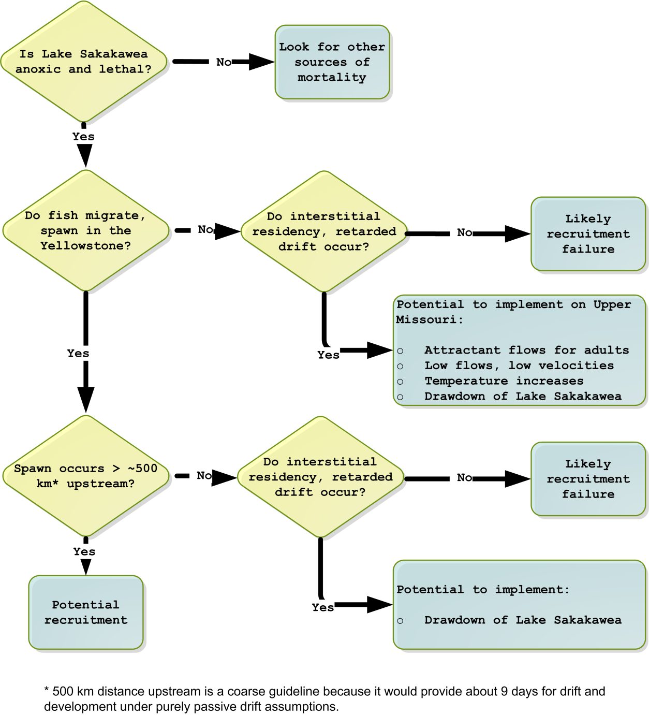

Figure 10. Diagram of a decision tree for contingent information on the Upper Missouri and Yellowstone Rivers (presented as Figure 64 in Chapter 4). Passage at Intake will result in approximately 400 km of drift.

If pallid sturgeon do not successfully spawn on the Yellowstone River but subsequently recruit at sufficient levels, then the ability to manage for spawning on the Missouri River may hinge on whether delayed drift (interstitial hiding) occurs. If it occurs, then potential actions include flow management (low flows), temperature management (increased temperature), or drawdown of Lake Sakakawea. The question of whether delayed drift (interstitial hiding) occurs is important to spawning on the Yellowstone River as well. The necessary upstream migration distance (and hence available drift distance) could be substantially reduced by interstitial hiding. Interstitial hiding is discussed further (see additional discussion in the EA summary, section 4.1.2).

Implementation of these other actions would require evidence from related Level 1 and Level 2 studies to suggest that some combination of actions would improve survival to first feeding in the Upper River. Each of the potential actions, with associated hypotheses, objectives, metrics, and decision criteria, are discussed in Chapter 4.

### Pallid sturgeon in the Lower Missouri River

Uncertainties for the Lower Missouri River center around how pallid sturgeon use the river, its tributaries, and the Mississippi River. Big Questions relate to possible actions to ensure survival and recovery of pallid sturgeon in the Lower Missouri River (see Table 5). In their framework for pallid sturgeon in the Lower Basin, the USFWS and Corps (2015) identified a suite of four actions anticipated to avoid jeopardizing pallid sturgeon in the Lower River, with associated targets and time limits for implementation (Table 7). The four actions include population augmentation, interception and rearing complexes (IRCs), spawning habitat, and (potentially) manipulation of flows.

The uncertainties in the Lower River will bereduced using the framework shown in Table 6. Level 1 and 2 studies are directly tied to those uncertainties and management hypotheses highlighted in the EA that, if resolved, could significantly affect the implementation of management actions. These are presented in detail in Appendix C.

The USFWS and USACE (2015) identified a suite of four actions that, subject to the findings of Level 1 and Level 2 studies and further ongoing coordination, that are anticipated to avoid jeopardizing pallid sturgeon in the Lower Missouri River. They also identified targets and defined time limits for implementation of these actions (Table 7). As knowledge is gained from Level 1, 2, and 3 actions, the timeframe for implementation may be adjusted, targets may be changed, management actions may be refined, and hypotheses may be dismissed. The “rules” by which these decisions will be made are outlined in the decision criteria for the respective management hypotheses, subject to the overarching governance and decision process laid out in Chapter 2 of this AM Plan. Chapter 4 of the AM Plan proposes a more accelerated timeline for high priority Level 1 actions (implemented in parallel rather than sequentially), as discussed in section 4.3.

Table 7. Summary of time limits for implementation and scope of actions.

|  |  |  |  |
| --- | --- | --- | --- |
| **Action Category** | **Time Limit\*** | **Minimum Scope** | **Maximum Scope** |
| Population augmentation | Immediate | Current stocking rate as directed by USFWS Basin-wide Stocking and Augmentation Plan | Variable over time as directed by USFWS Basin-wide Stocking and Augmentation Plan |
| IRC habitat development | Stage 1 - study phase (years 1-3 post-ROD) | Build 2 IRC sites per year (paired with control sites), adding 33,000 ac-d/yr of suitable habitat, using staircase design1. Assess potential for refurbishing existing SWH sites as IRCs. | |
| Stage 2 – continue study phase (years 4–6 post-ROD) | Build 2 IRC sites per year (paired with control sites), adding 33,000 ac-d/yr1 of suitable habitat. Refurbish SWH sites in addition to study sites (rate TBD). | |
| Stage 3 - Level 3 implementation (years 7–10 post-ROD) | Continue assessing IRC sites and refurbishing new SWH sites, adding at least 66,000 ac-d/yr1 of suitable habitat. Determine required rate of Level 3 implementation based on stages 1 and 2. | |
| Stage 4 – Level 4 implementation | Remove IRC habitat limitations to pallid sturgeon survival by implementation at Level 4. | |
| Spawning habitat2 | 2 years | 1 spawning site | See decision tree in Figure 78 |
| Spawning cue flows | 9 years | Requirement for spawning cue flows (and appropriate scope) depends on the outcome of Level 1 and Level 2 monitoring and modeling studies during years 1–9. 3 | |

**Notes**

1. Units of ac-d/year are calculated based on how the flow regime and channel configuration result in cumulative days of availability of suitable habitat during the growing season. Progression through each stage of IRC habitat development is contingent on outcomes and hypothesis tests (USFWS 2016); efforts could be halted if evidence shows IRCs are not successful. Experimental design for IRC sites, and associated metrics, are described in section 4.2.6.3 and Appendix E. Refurbishment of SWH sites into IRCs is described in section 4.2.6.4.

2. Anticipated as a Level 2 pilot project focused on developing and evaluating high-quality spawning habitat. Spawning habitat implementation will be guided by the decision tree in section 4.2.6.3 (Figure 78 ). The evaluation of spawning areas will be based on comparing attraction, egg survival, and hatch to existing spawning areas (see section 4.2.6.5).

3. See evidentiary framework in Table 48, section 4.2.6.6. Pallid population modeling will be used to set minimum spawning flow needs. Bird impacts and status, reservoir levels, and HC impacts will inform decisions regarding spawning cue flows below Gavins Point Dam in any particular year.

At any time during the Framework’s implementation, it may become apparent that: (1) a particular action is not needed, (2) a proposed action requires modification to be effective, or (3) that some new action not previously evaluated is required.

The artificial propagation program is already taking place at a level having a measurable effect on the population (i.e., Level 3) As knowledge is gained from Level 1, 2 and 3 studies, the timeframe for implementation may be adjusted, targets may be changed, management actions may be refined, and hypotheses may be adjusted or rejected. The “rules” by which these decisions are made are outlined in decision criteria for the respective management hypotheses, subject to the overarching governance and decision process laid out in Chapter 2. Chapter 4 proposes a more accelerated timeline for high priority Level 1 actions (implemented in parallel rather than sequentially), as discussed in Section 4.3.

Improvements to address genetic concerns (e.g., maintaining genetic variation similar to the natural population, minimizing threats of hybridization), disease, stocking size, amount of stocking relative to carrying capacity, etc., would be pursued collaboratively with the USFWS and others to be consistent with the Basin-wide Stocking and Augmentation Plan under development by the USFWS. While population augmentation is *necessary* for recovery of the pallid sturgeon, by itself it is not *sufficient* as the ESA requires a self-sustaining population. Augmentation can help severely depleted populations recover numbers of individuals sufficiently to provide reliable evaluations of the effectiveness of alternative actions.

Level 1 and 2 activities associated with IRCs focus on: (1) the need for additional IRC habitat, (2) refining the relationship between the habitat components and flow (utilizing current operations), and the biological requirements of each habitat type, (3) the needed habitat characteristics and their spatial and temporal distributions, and (4) determining the effectiveness of various mechanical activities and the potential for flow management actions to contribute to future IRC needs. Level 3 actions include physical manipulation of habitats and structures on the Missouri River to create or improve areas having hydraulic conditions to intercept drifting free embryos combined with food-producing habitats and foraging habitats. Actions can be directed at one or any combination of the three components of IRCs. Examples include adjustments to navigation training or bank stabilization structures, channel widening, floodplain modifications or other adjustments to channel geometry, placement of structures to encourage development of needed habitat or habitat complexity, chute development or adjustments to existing chutes, etc. Level 3 actions and outcomes are focused on helping to understand and describe future Level 4 actions and targets, which will be based on bioenergetics requirements of the Missouri River pallid sturgeon population. An experimental design and monitoring plan for IRCs is included in Appendix E of this AM Plan; it involves 12 treatment-control pairs implemented over 7 years (see Appendix E).

The spawning habitat hypothesis (H16) provides an example of application of actions at Level 1 and 2 to reduce critical uncertainties affecting management decisions and targets. An early emphasis will be to utilize information from spawning habitats in the Yellowstone River as the best natural reference condition to inform the design of Level 2 pilot projects on the Lower Missouri River, while also continuing to examine the habitat characteristics of spawning sites on the Lower Missouri. Initially only one spawning habitat would be constructed on the Lower Missouri, in a location and form which maximizes the potential for aggregation of males and females. This pilot project will be monitored for effectiveness based on metrics ranging from observed aggregation and spawning to the number of free embryos in the water column (described in section 4.2.6.5.5 on metrics).

Another example of applying Level 1 research within the Framwork is testing the spawning cue hypothesis, H11 (see Table 5). Observational studies (tracking tagged pallid sturgeon movements and spawning over contrasting flow conditions) would), are to be completed during a period of 9 years after the ROD. Analyses of these data and application of an evidentiary framework will then be used to determine whether it is appropriate to implement a Level 2 action – testing spawning cue flows at Gavins Point. The evidentiary framework will examine the correlations between flows and movement, aggregation, and spawning success, using tagged pallid sturgeon in reproductive condition. Testing hypothesis H11 involves both temporal and spatial contrastsKey points and other issues

The uncertainties for the pallid sturgeon are both extensive and fundamental to management strategies. Therefore, AM for pallid sturgeon will rely heavily upon research conducted in conjunction with the implementation, monitoring, and adjustments of management actions. This research has been prioritized to focus on critical uncertainties that have a strong influence on decision trees. Early implementation of actions will generally be of an experimental nature (i.e., Level 2) and could involve several concurrent studies that are potentially confounding. This will require careful consideration of what studies will be implemented and when, along with sound experimental designs.

*Additional key figure on next page:*

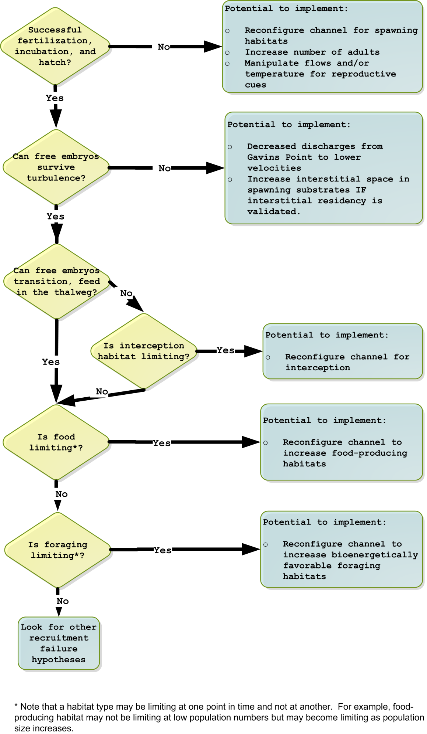

Figure . Diagram of a decision tree addressing contingent information in the Lower Missouri River. Modified from Jacobson et al. 2016a.

## Human Considerations (HC)

## Data acquisition, management, reporting and communications

## Summary

# Governance of the AM Program

# Adaptive Management for Plovers and Terns

# Adaptive Management of Pallid Sturgeon in the Missouri River

This chapter is organized according to the steps of the AM cycle introduced in   
Section 1.1.5:

1. Assess (Section 4.1), which provides goals and objectives for pallid sturgeon, and also summarizes the EA (Jacobson et al. 2015a, 2015b, 2016a, 2016b; Delonay et al. 2016b);
2. Plan and Design (Section 4.2), which summarizes metrics and decision criteria for Level 1 and Level 2 components, and describes the design of Level 3 actions (including hypotheses, action descriptions, objectives, expected benefits, metrics, experimental design, decision criteria, and Level 3 contingent actions);
3. Implement (Section 4.3) describes the current schedule for implementation of Level 1, 2 and 3 actions. This schedule will be further revised over time.
4. Monitor (Section 4.4), which summarizes the metrics used for monitoring each Level 2 and 3 action currently under consideration;
5. Evaluate (Section 4.5), which summarizes the evaluation approaches used for each Level 2 and 3 action; and
6. Decide (Section 4.6), which summarizes the decision criteria for each Level 2 and 3 actions.
7. Section 4.2 also incorporates much of the material from the Lower Missouri River Pallid Sturgeon Framework, Targets and Decision Criteria (USFWS and USACE 2015, USFWS 2015a, USFWS 2016). This chapter is associated with several appendices:
8. Appendix C contains details of the design of Level 1 and 2 actions.
9. Appendix D describes the protocol to be used for population monitoring, and the structure of the population model that’s closely associated with the population monitoring
10. Appendix E [*in progress*] lists other monitoring protocols not contained in Appendix C.
11. Appendix F contains detailed cost estimates for Level 1 and Level 2 science components.

Relative to birds, there is a greater level of uncertainty about the most appropriate management actions to maintain and recover pallid sturgeon populations in the Missouri River. Therefore, the approach described in this chapter involves a greater investment in research to reduce critical uncertainties that affect management decisions, and in rigorous monitoring of well designed pilot actions (Level 2) to evaluate their effectiveness.

## Assess

### Goals and management objectives for pallid sturgeon

In 2013, the USFWS (written com., September 12, 2013 [Draft Species Objectives, p. 1]) developed the following fundamental objective for pallid sturgeon in the Missouri River:

*Fundamental Objective: Avoid jeopardizing the continued existence of the pallid sturgeon from the U.S. Army Corps of Engineers actions on the Missouri River.*

The USFWS notes that this objective is consistent with species recovery goals (U.S. Fish and Wildlife Service, 2014) but specific to Missouri River management actions.

In 2013, the USFWS also proposed the following two sub‐objectives (both measurable), which must be attained to ultimately achieve the stated “fundamental objective”. The intent of the sub‐objectives is to provide direction in the short term, provide objectives meaningful for AM, and focus efforts on the desired short term outcomes while keeping the fundamental objective in mind. Although attaining a self-sustaining population is the desired outcome of the Revised Pallid Sturgeon Recovery Plan (USFWS 2014), described below under sub-objective 2, we may be decades away from such an objective being very meaningful. If natural recruitment were achieved in 10 years, it could take 20 to 30 years before progress toward the self‐sustaining population objective could be assessed. Modeling can give projections and insights into the probability of achieving the fundamental objective under proposed and implemented actions. The two sub-objectives provide guidance for the actions, monitoring and research required to support the fundamental objective over the longer term.

*Sub‐objective 1: Increase pallid sturgeon recruitment to age 1.*

**Metrics:** primary metric is catch rates of age 0 and age 1 pallid sturgeon; secondary metrics include model-based estimates of abundance of age 0 and age 1 pallid sturgeon, and the survival of hatchery and naturally reproducing fish to age 1.

**Target:** TBD. The short‐term target is to demonstrate measurable recruitment to age 1, and hopefully increasing levels of recruitment over time. Recruitment is emphasized in sub-objective 1 since wild-spawned young-of-year (YOY) or juvenile pallid sturgeon have not been captured in the Upper Missouri River upstream of Lake Sakakawea, and have been captured only rarely in the Lower Missouri River (Jacobson et al. 2016a). Until 2015, there had been no documented captures of genetically identified, wild-spawned pallid sturgeon free embryos, larvae, or YOY in the lower river (U.S. Fish and Wildlife Service, 2014). Recent data indicate that limited recruitment is happening in the Lower Missouri River, but not at a level sufficient to maintain the population (U.S. Fish and Wildlife Service, 2014; Jacobson et al. 2016a). Multiple factors can potentially be limiting recruitment (see Appendix B, Figures B.9, B.10 and B.11).

The long‐term target for recruitment (i.e. necessary levels and frequency of recruitment over time) will be informed by the EA (Jacobson et al., 2016a) and collaborative population model (Section 4.1.2.3 and Appendix D of this plan), following the necessary monitoring, model validation, and supporting research. Defining the long term target is not critical in the near-term as the immediate priority is to establish measurable recruitment. Possible targets could include a modeled egg to age-1 survival rates sufficient to result in growth and sustainable population size.

*Sub‐objective 2: Maintain or increase numbers of pallid sturgeon* as an interim measure *until sufficient and sustained natural recruitment occurs.*

**Metric:** Population estimates for pallid sturgeon for all size and age classes, particularly for ages 2 to 3 to assess recent trends in recruitment; catch rates of all pallid sturgeon by size class (to maintain legacy data). Age classes will be estimated as an output metric of the population model that will be validated through recaptures of tagged fish. There are challenges in quantifying a population size for age 2-3 year old pallid sturgeon as there is a lot of overlap in the lengths of fish aged 2 to 5 years. Further work is required to refine population metrics, which may include estimating a population size for a subset of the length frequency distribution.

**Target:** TBD. Possible targets could include: 1) positive population growth rates (i.e., lambda (λ) > 1) of pallid sturgeon age 2 and older; 2) estimated survival rates of all size/age classes sufficient to provide a stable population of pallid sturgeon age 2 and older; and 3) acceptable probabilities of persistence and recovery over a 50 to 100 year time frame (utilizing population models). For example, the Lower Missouri Framework (USFWS and USACE 2015) described two preliminary decision criteria for halting population augmentation: 1) when population monitoring demonstrates a self-sustaining population in excess of 5000 adult fish in each management unit; and 2) when the threat of extirpation is less than 5 percent in 50 years, or as based on new criteria introduced through the Basin-wide Stocking and Augmentation Plan. The criteria recommended in USFWS and USACE (2015) are similar to those in the Revised Recovery Plan for the Pallid Sturgeon for reclassifying pallid sturgeon from endangered to threatened status (UFSWS 2014, pg. 54):

“Pallid Sturgeon will be considered for reclassification from endangered to threatened when the listing/recovery factor criteria are sufficiently addressed such that a self-sustaining genetically diverse population of 5,000 adult Pallid Sturgeon is realized and maintained within each management unit for 2 generations (20-30 years). In this context, a self-sustaining population is described as a spawning population that results in sufficient recruitment of naturally-produced Pallid Sturgeon into the adult population at levels necessary to maintain a genetically diverse wild adult population in the absence of artificial population augmentation. Metrics suggested to define a minimally sufficient population would include incremental relative stock density of stock-to-quality-sized naturally produced fish (Shuman et al. 2006) being 50-85 over each 5-year sampling period, catch-per-unit-effort data indicative of a stable or increasing population, and survival rates of naturally produced juvenile Pallid Sturgeon (age 2+) equal to or exceeding those of the adults (see Justification for Population Criteria below [in USFWS 2014] for details). Additionally, in this context a genetically diverse population is defined as one in which the effective population size (Ne) is sufficient to maintain adaptive genetic variability into the foreseeable future (Ne ≥ 500), conserve localized adaptions, and preserve rare alleles.”

In addition to the fundamental objective and associated sub-objectives, there are a set of proposed actions to be implemented on the Missouri River, which are the means of achieving the fundamental objectives and sub-objectives. The timelines for these actions serve as a backstop to ensure that the rate of implementation of management actions on the Missouri River is not hindered by an inability to learn from applied science efforts. In effect, they define necessary levels of implementation at a point in time for each hypothesis, and must be met unless the learning from applied science efforts demonstrates that the in-river actions associated with that hypothesis are unnecessary.

#### Geographic scopes of the Effects Analysis, MRRP-EIS and this AM Plan

The geographic scope of the Pallid Sturgeon EA was larger than the scope of the MRRP-EIS and this AM Plan. The area considered in the EA included the Upper Missouri River mainstem from Fort Peck Dam to the headwaters of Lake Sakakawea, the Yellowstone River upstream of the confluence with the Upper Missouri River for an unspecified distance, the Lower Missouri River mainstem from Gavins Point Dam to confluence with the Mississippi River at St. Louis, tributaries used by pallid sturgeon, and an unspecified distance downstream in the Mississippi River (Figure 58). The distance downstream in the Mississippi River is unspecified because presently available information (2015) is ambiguous about the extent to which Missouri and Mississippi river populations mix through migrations and dispersal. Recent information suggests that adult pallid sturgeon originating in the Missouri River are frequently found in the middle and upper Mississippi River (Porecca et al. 2015).

This geographic scope was constrained in part by the decision-making authority of the USACE and in part by present understanding of the geographic distribution of pallid sturgeon. Literature and ongoing research from outside this defined area was utilized where it helped to inform hypotheses evaluated in the EA. The reservoirs and inter-reservoir reaches (from Lake Sakakawea to Lewis and Clark Lake) were excluded from the effects analysis based on the assumption that these habitats are unlikely to support reproductive populations of pallid sturgeon. Figure 59 shows the area that is the main focus of research into potential management actions to recover the pallid sturgeon population in the Upper Missouri River.

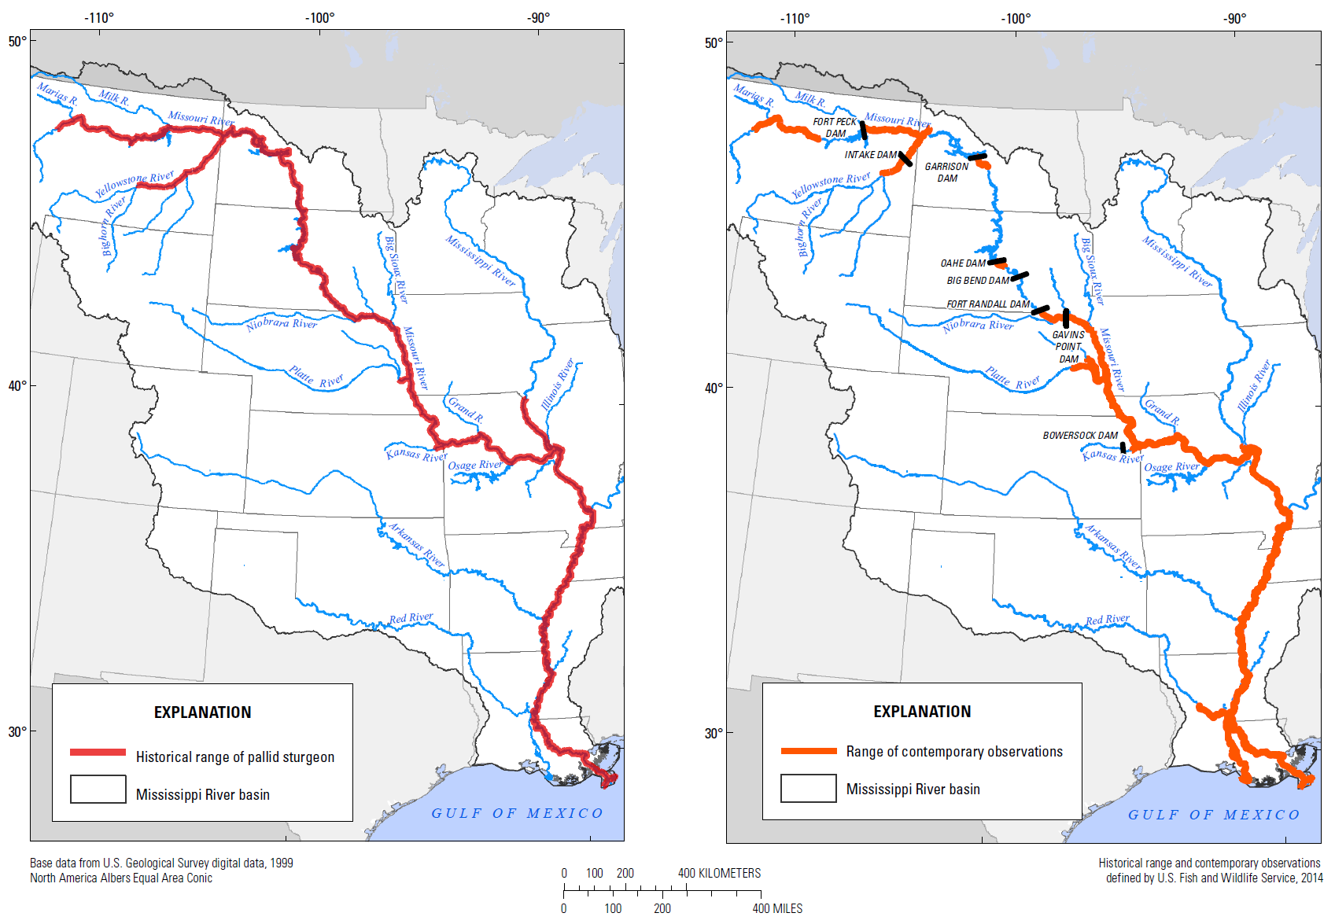

Figure 58. Historical range and present-day occupancy of the pallid sturgeon and scope of the Missouri River included in the EA. Present day occupancy shown on the right side map includes the stretch of the river above Gavins Point Dam and below Fort Randall Dam, which is not included in the defined area of the Lower Missouri River. Pallid sturgeon may be found in reservoirs but do not prefer these habitats. Source: Figure 2 in Jacobson et al. 2016a

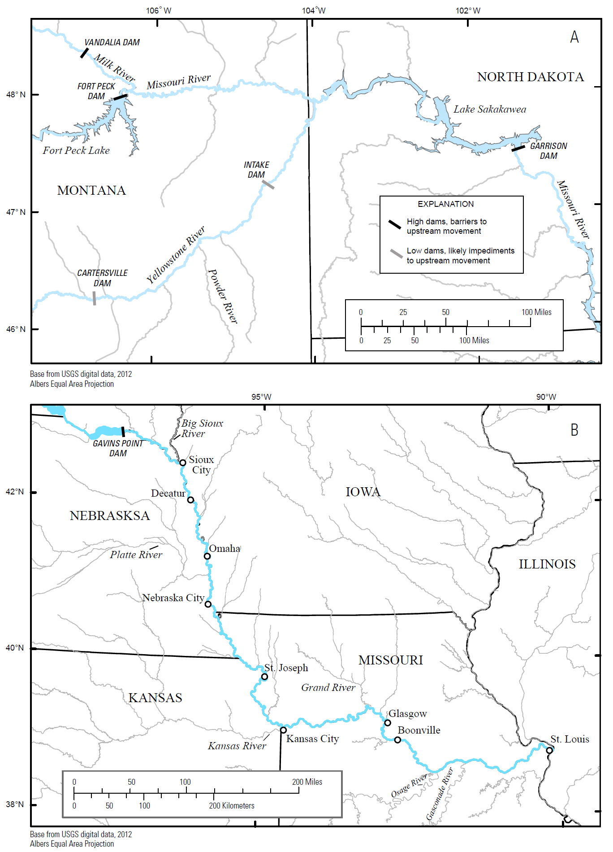

Figure 59. Map of the upper (A) and lower (B) river complex, showing the Yellowstone and Missouri Rivers, major tributaries, and reservoirs. Black lines are absolute barriers; gray lines are likely barriers, including run of river weirs.

Management of Missouri River pallid sturgeon has historically occurred over four Recovery Priority Management Areas or RPMAs, and is now organized around four Management Units (described in section D.1.3 of Appendix D, and Figure D.1). The area upriver of Fort Peck Reservoir (former RPMA 1) is outside of the geographic scope of the MRRP. The geographic scope of the MRRP (and this AM Plan) includes those portions of the Missouri River encompassed by the portion of the Great Plains Management Unit (GPMU) below Fort Peck Lake, the Central Lowlands Management Unit (CLMU), and the portion of the Interior Highlands Management Unit (IHMU) above the confluence of the Missouri and Mississippi Rivers (MRRMP-EIS, Section 1.8.1), corresponding to the historic RPMA’s 2-4 (Figure D.1). The USACE has jeopardy responsibilities for pallid sturgeon under the ESA in these three RPMA’s. The Yellowstone River is the only tributary included in the geographic scope of the MRRP-EIS, due to its importance to pallids in RPMA #2, and the effects of the Intake Dam. The Platte River has been utilized by pallid sturgeon and information from the Platte River is relevant to an understanding of pallid sturgeon populations in the Lower Missouri River, but the Platte River is not wihin the geographic scope of the MRRP and the AM Plan. As occurred during the EA, literature and ongoing research from outside the geographic area defined for the MRRMP-EIS (e.g., upstream of Fort Peck Dam) may be utilized where it helps to inform the evaluation of hypotheses and potential management actions.

### Key findings from Effects Analysis and more recent work

#### Purpose and methods of the EA

#### Overall conceptual model

Conceptual ecological models (CEMs) illustrate population dynamics at the population level, and show the linkage between management actions, ecological factors, and biological responses (Jacobson et al. 2015b). The generalized population-level conceptual model in Figure 61 was adapted from Figure 3 in Jacobson et al. 2015y. This conceptual model demonstrates the conditions, processes, and potential management actions that affect survival at critical life-stage transitions. In Figure 61, squares represent different life-stages with arrows in the direction of development. Life-stage transitions are influenced by the survival probability (diamonds) and the conditions, processes, and management actions influencing survival (ovals and icons). The conceptualized river in the middle of the graphic demonstrates the use of the river mainstem or its tributaries during different life-stages (Wildhaber et al. 2007).

… <material removed> …

The two classes of management actions represented in the figure are channel management and restoration, and reservoir engineering and operations. Channel management and restoration options include channel reconfiguration, interception and rearing complexes, spawning habitat creation, bank stabilization and in-river structures to alter velocities or flow paths. Reservoir engineering and operations include operating rules (e.g., flow pulses, drawdown), passage structures, and structures or actions to improve water quality (e.g., temperature, sediment, oxygen).

Life-stage component CEMs were developed by Jacobson et al. (2015b) to illustrate the driver-stressor relationships influencing survival of that life-stage transition. These life-stage transition survival probabilities correspond to the diamonds in Figure 61. Survival at each life history stage is a function of the conditions and processes which occur during that stage, which in turn are potentially affected by different management actions. Figure 61 also shows potential stocking activities (which historically have included stocking at free embryo, exogenously feeding larvae / fingerlings / younger yearlings (all < 1 year old), and juveniles / older yearlings) and broodstock collection of spawning adults.

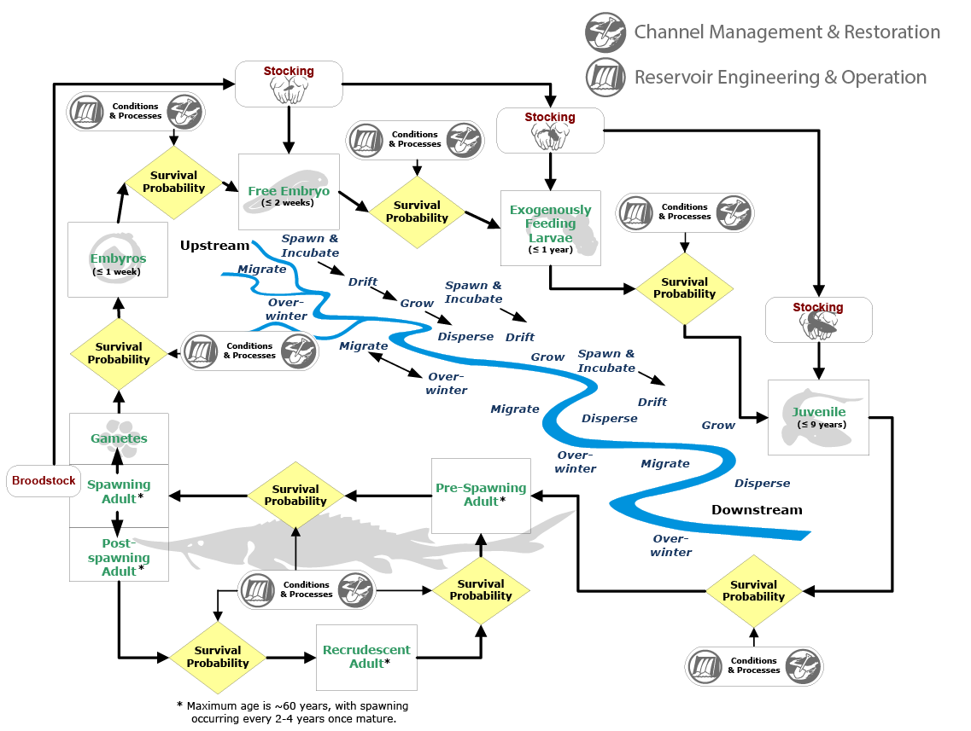

Figure 61. Generalized population-level CEM showing life stages, geographic context of pallid sturgeon reproductive cycle. Fingerlings and yearlings less than 1 year old fit into the “exogenously feeding larvae” life stage.

Figure 62 is an example of a life-stage component CEM. Each pair of columns, from left to right can be considered a cause-effect linkage, with the final rightmost column being the ultimate biotic response (Jacobson et al. 2015b). The classes of factors that were considered include (from left to right in Figure 62): anthropogenic or geologic independent drivers, management and restoration activities, primary ecological factors, secondary ecological factors, primary biotic responses, and ultimately the secondary biotic response of survival of that life-stage (yellow diamond). The conceptual model uses a hierarchical structure of factors, whereby bounding boxes represent broad descriptions of ecosystem factors and are common across all component CEMs, and the colored boxes within each column are more specific factors which may vary depending on the life-stage and location of the component CEM. Hypothetical relationships between the factors were explicitly mapped out in a workshop process involving experts in pallid sturgeon biology and Missouri River processes. Participants at these workshops characterized each relationship by its relative importance and uncertainty. The relative importance ranking used line weight used in Figure 62 (solid, dashed, and dotted lines, where solid represented the highest relative importance), and the uncertainty ranking used line color (black–least uncertainty, blue–moderate uncertainty, and red–most uncertainty). These hypothetical relationships provide the basis for the global hypotheses for the EA (Section 1.4.2).

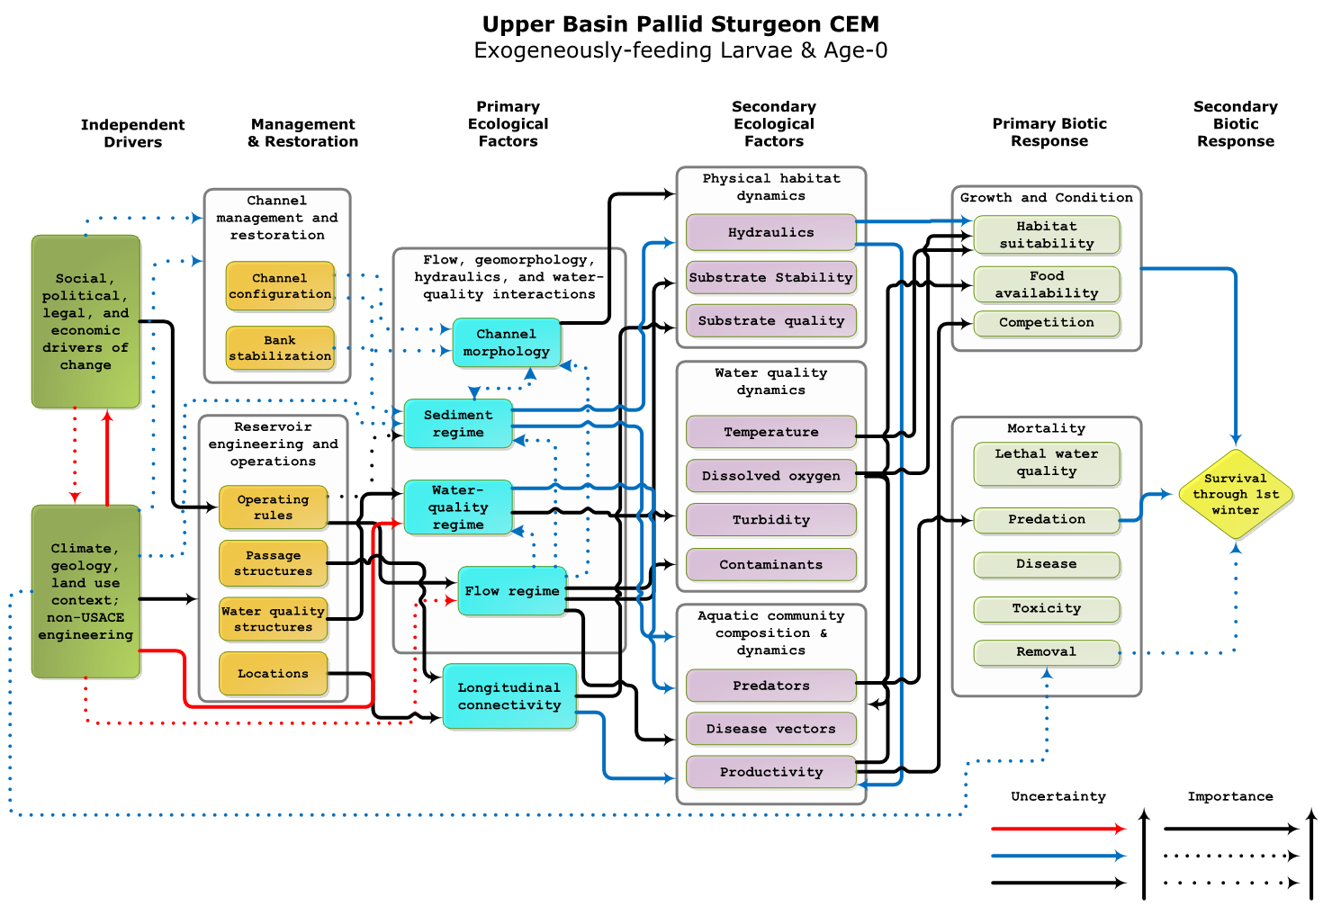

Figure 62. Example of a life-stage component CEM showing the cause-effect linkages leading to survival to the next life-stage (Jacobson et al. 2015b).

#### Collaborative population dynamics model

The collaborative pallid sturgeon population model (Jacobson et al. 2016a; Appendix D, section D.4.3) serves as a central tool to organize, assimilate, and evaluate information on Missouri River pallid sturgeon populations. The primary purpose of the model is to evaluate the population-level effect of management actions and provide metrics (e.g., population viability, abundance) that link to fundamental objectives for pallid sturgeon. The description of the model presented here is a snapshot of the current state of the model, which has expanded in scope since the EA was developed. The models are the quantitative statement of hypotheses. Expressing hypotheses in a quantitative form reveals where the most critical uncertainties exist in our understanding of functional relationships (i.e., uncertainties in key inputs to decisions), which helps to prioritize data collection and small-scale experiments. The models also provide a mechanism for extrapolating observed changes at specific life-history stages (from field data) to their long term population consequences, and propagating the inherent uncertainties in life-stage specific survival probabilities (the diamonds in Figure 61). The structure of the model mimics the structure of the revised population assessment program, as described in Appendix D. This will provide benefits in both directions: essential empirical data for model calibration, testing and application; and use of the model to design the most cost-effective data collection procedures, explore alternative hypotheses, and evaluate the long term consequences of current and proposed actions for fundamental and sub-objectives.

The development of the stage-based collaborative model has several advantages over previous age-structured models (e.g., Reynolds and Tyre 2011, Steffensen et al. 2013a, Wildhaber et al. 2015. First, the collaborative model explicitly models all life-stages. Specifically, there are several early life history stages that participants believed required their own conceptual ecological models, including gametes, embryos, free embryos, exogenously feeding larvae, and age-0 fish. The collaborative population model faithfully represents the work of the participants who developed the component CEMs. Second, the collaborative model has a flexible model structure template to model several populations (i.e., upper river, lower river, and sub-populations if identified) at varying spatial resolutions. Previous models were constrained to either the upper and lower basins with most effort in the lower basin and a strong bias towards the lower basin population (Jacobson et al. 2015b). Finally, the development of the collaborative model occurred through a transparent process involving input from potential users using open-source software with public-domain source code and open accessibility to an online version. This tool will evolve and be modified to meet the AM process needs and the community of scientists engaged in understanding pallid sturgeon population dynamics.

The geographic extent of the current model is limited to segments of the lower and upper Missouri River (Figure 58). These two parts of the Missouri are subdivided into bends representing the spatial grain of the population model. River bends are defined as three continuous habitats (channel cross-over, inside bend, outside bend) and vary in number and size from the lower to upper basin[1]. Bends are used as a spatial organization for the model, to accommodate movement of fish among bends in the model, and because bends are the sampling units for the Pallid Sturgeon Population Assessment Program (PSPAP). The current temporal extent (duration of model runs) is user defined and can be up to 50 years with a monthly time step.

The model requires basin-specific demographic rates and values (e.g., survival, fecundity, sex ratio) and values for state variables (e.g., number of hatchery fish, number of natural fish) to simulate population dynamics. Uncertainty is associated with most of these inputs, though the number of stocked fish is known precisely. Inputs are derived from literature and from experts within the basins. The population model is initialized by drawing demographic values and rates from distributions. Next, state values (i.e., number of hatchery or natural origin fish) are drawn from distributions. Age structure is then initialized given the abundance and demographic rates drawn. For example, if 4000 natural origin fish were stochastically selected, those fish are then allocated to an age class given their cumulative probability of surviving, yielding the typical exponential decay in number of fish with age. Model initialization makes an assumption of population equilibrium as in past modeling studies (Steffensen et al. 2013), which basin experts agreed was reasonable. This assumption takes into account the fact that, even in the absence of recruitment, population declines are expected to be relatively small for a long-lived fish with high sub-adult and adult survival.

Current model implementation outputs the origin and fate of individual fish (i.e., natural, hatchery, mortality) for each time step over the years simulated. When multiple stochastic replicates are simulated, values can then be post-processed to forecast values like pseudo-extinction probabilities. Additional post-processing includes a function to simulate a robust design capture-recapture program so that the model can be used to inform population monitoring designs (discussed in section 4.4 and Appendix D).

The ultimate objective for the population model is to evaluate management actions propagated through the pathways described in the CEMs. There are many gaps in biological understanding linking primary and secondary biotic responses. Current model implementation accepts demographic rates; however, direct effects of primary biotic responses are uncertain or unknown. These uncertainties and unknowns aside, the model framework development is focused at further development of the capacity to evaluate primary biotic responses in two approaches. The first approach modifies the demographic rate distributions as a function of a primary biotic response. For example, the current model represents demographic rates in terms of a baseline survival rate, the uncertainty in that survival rate, and potential changes in the survival rate as a function of other factors (e.g., amount of food available for exogenously feeding larvae in interception and rearing habitat). The mathematical form of these functions is described in Appendix D, section B.4.3.3.

Sensitivity analyses of parameters in the collaborative population dynamics model confirmed that early life-stage survival values were the most uncertain and have the most leverage on population dynamics. Further, the EA team used the model to explore how the persistence of pallid sturgeon in the Missouri River varied with different levels of stocking. Parameter estimates generated from the modeling included estimates of early life-stage survival rates needed to sustain a population under current stocking rates. These numbers provide benchmarks to evaluate stocking and ongoing refinement of survival rates. The early life-stage survival rates also represent a key parameter uncertainty in the model (gamete, embryo, free embryo, exogenously feeding larvae, age-0) because there are limited data on these probabilities. Another source of uncertainty is the spatial dynamics including flow cues as a trigger for movement and flow modifications for drift of free embryos. An additional complicating factor (not included in the model) is hybridization between pallid sturgeon and shovelnose sturgeon (Jacobson et al. 2016a), albeit hypothesized genetic consequences on population demography are not well understood. The model’s structure and proposed applications are closely aligned with the proposed revisions to monitoring of pallid sturgeon populations, as described in Appendix D.

#### Initially modeled hypotheses and process for examining additional hypotheses

#### EA findings, critical uncertainties, potential actions and decision trees

## Plan and Design

### Pallid sturgeon framework

<< material removed >>

Table 40 Current status of actions under consideration for both the Upper and Lower Missouri River, and relative priority of investigations at each level.[2] Details of the formulation of alternatives and the rationale for decisions on these alternatives will be included with the release of the Draft EIS in December 2016.

| **Action location** | **Action** | **Current level of implementation and relative priority** | | | **Comments** |
| --- | --- | --- | --- | --- | --- |
| **Level 1** | **Level 2** | **Level 3** |
| **Upper Missouri River** | **Alter Flow Regime at Fort Peck** | Low | Depends on results of Level 1 |  | Continue to investigate biological benefits with better information on interstitial residency and movement rates of embryos at Level 1. Not currently included in Preferred Alternative, but one possible outcome of research studies and AM experiments (see Figure 63). |
|
|
| **Temperature Control, Fort Peck** | Low | Depends on results of Level 1 |  | Continue to investigate biological benefits at Level 1. Not currently included in Preferred Alternative, but one possible outcome of research studies and AM experiments (see Figure 63). |
|
| **Sediment Augmentation at Fort Peck** | Low | Depends on results of Level 1 |  | Continue to investigate at Level 1. Not currently included in Preferred Alternative. |
| **Yellowstone River** | **Passage at Intake** | High | High | High | This action and associated evaluations of effectiveness have been determined to be a high priority by the USFWS in coordination with the USACE and Reclamation for the Upper Missouri[3]. |
| **Upper Missouri and Yellowstone** | **Upper Basin Propagation** | High | High | High | The Recovery Team and participating federal agencies are considering several potential changes to the propagation program, including the number, age and genetics of stocked fish, and stocking locations. The new information analysis of the fish condition (section 4.1.2.5) may lead to additional EA hypotheses concerning propagation. The experimental designs described in section 4.2.5.1 of the AM Plan are applicable to multiple potential action hypotheses. Included in Preferred Alternative. Amount of augmentation could be decreased significantly in the next Basin-wide Stocking and Augmentation Plan |
|
| **Lake Sakakawea** | **Drawdown, Lake Sakakawea** | Low | Depends on results of Level 1 |  | Continue to investigate biological benefits with better information on interstitial residency and movement rates of embryos at Level 1. Not currently included in Preferred Alternative, but one possible outcome of research studies and AM experiments (see Figure 63). |
| **Lower Missouri River** | **Alter Flow Regime at Gavins Point** | Medium-High | Medium-High after 9-year period post-ROD, depending on results of Level 1 studies | Medium-High after 9-year period post-ROD, depending on results of Level 1 and Level 2 studies | Spawning cue flows will be a high priority Level 1 investigation. Naturalization of the flow regime at Gavins Point will be a medium priority Level 1 investigation. Not currently included in Preferred Alternative, but might be implemented as a test flow following 9 years of study post-ROD (see Figure 64 and section 4.2.6.6). |
|
|
| **Temperature management, Fort Randall** | Low | Depends on results of Level 1 |  | Not currently included in Preferred Alternative, but one possible outcome of research studies and AM experiments (see Figure 64). |
| **Channel Reconfigu--ration** | High | High | High | Construction of habitat to support early life history survival (e.g., Interception and Rearing Complexes, Spawning Habitats) is included in the Lower Missouri Framework. Included in Preferred Alternative. |
|
|
|
| **Propagation Lower Basin** | High | High | High | As described above for the Upper Missouri River. The experimental designs described in section 4.2.6.1 of the AM Plan are applicable to multiple potential action hypotheses. Included in Preferred Alternative. |
|

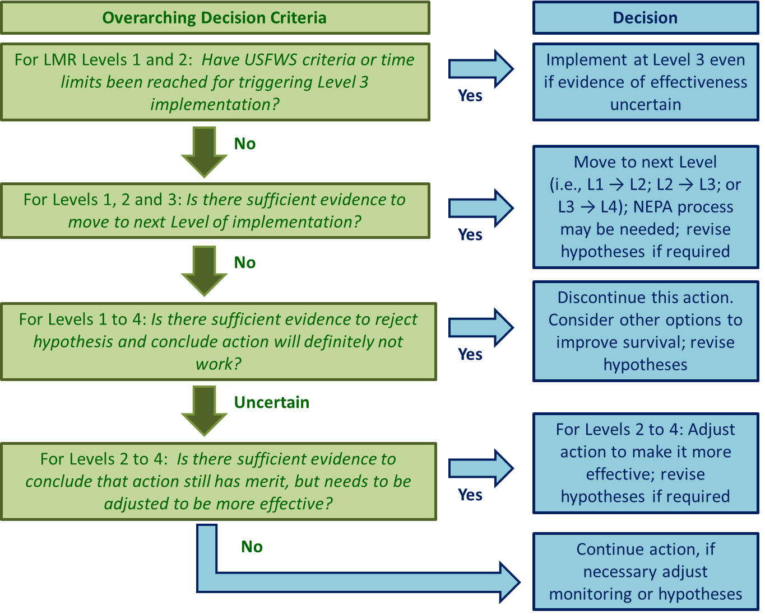

Figure 65 Overview of the decision criteria for various decisions in the Pallid sturgeon framework. The top green box refers to the decision criteria in Table 41 and Table 42. The remaining green boxes refer to the evidence and decision criteria in Appendix C, Table 43, Table 44 and Table 53. The blue box second from the bottom (“Discontinue this action, consider other options to improve survival”) is illustrated by the decision trees in Figure 63 and Figure 64

#### Level 3 Actions, Targets and Decision Criteria:

### Tradeoffs between different learning strategies

### Recommended learning strategy for AM Plan

### Overview of Level 1 and 2 Components and Decision Criteria

<< material removed >>

Table 43. Overview of highest priority Level 1 and 2 science components for the Upper Missouri, anticipated to be completed within the first five years of the Record of Decision (ROD) (subject to budget and resource constraints). Appendix C contains a complete list of all Level 1 and 2 components, and Appendix F describes the prioritization process. Components listed in Appendix C but not in this table could be implemented beyond the 5-year, post-ROD period. Metrics and decision criteria with associated degrees of certainty for the working management hypotheses are summarized from Appendix C. Categories for Degree of Certainty: 1 = Definitive, 2 = Statistically rigorous, 3 = Indicative but not authoritative, 4 = Expert judgment of multiple lines of evidence required. BQ = Big Question, L = Level, C = Component (e.g., BQ1/L1/C2 is Big Question 1, Level 1, Component 2). Work under BQ6 subject to Recovery Team discussions and Propagation Strategy. Hypotheses are from Table 1 in Jacobson et al. 2016a.

| **Question, Level and Study Components** | **Key Metrics** | **Simplified IF - THEN Decision Criteria** | **Degree of  Certainty\*** | **Concurrent / Dependent Components** |
| --- | --- | --- | --- | --- |
| **Big Question 1 – Spawning Cues:** Can spring pulsed flows from Fort Peck synchronize reproductive fish, increase chances of reproduction and recruitment? | | | | |
| **Associated Hypotheses:**  **H2.** Attractant flow releases at Fort Peck will result in increased reproductive success through increased aggregation and spawning success of adults. | | | | |
| BQ1/L1/C1--Design study: complementary passive telemetry network | Detectability of telemetry tags by network receivers, variation of tag detectability with discharge-related characteristics, tag cost, tag reliability. | IF fish movements past strategic locations are successfully detected, THEN deploy a larger network of telemetry receivers to help evaluate sturgeon response to flow. | 1 | C1-C2 all concurrent. Also with design of lower basin telemetry network (Table 39 - BQ1/L1/C1) |
| BQ1/L1/C2 – Field study: opportunistic tracking of reproductive behaviors | Degree of association of reproductive behaviors and successful spawning with monitored hydrologic characteristics. | IF there are moderate to strong associations between hydrologic characteristics and reproductive behavior, THEN this provides stronger evidence for L2 studies. However, IF successful reproductive behavior is observed in the absence of the hypothesized hydrologic characteristics AND is sufficient to have a population-level effect THEN this provides evidence against hypothesis H2. | 4 | C1-C2 concurrent |
| **Big Question 2 – Food and Forage:** Can naturalization of the flow regime from Fort Peck contribute to increased food production, foraging habitat, and survival of age-0 sturgeon? | | | | |
| **Associated Hypotheses:**  **H1.** Naturalized flow releases at Fort Peck will result in increased productivity through increased hydrologic connections with low-lying land and flood plains in the spring, and decreased velocities and bioenergetic demands on exogenously feeding larvae and juveniles during low flows in summer and fall. | | | | |
| No science components prioritized for first five years after ROD for BQ2 and H1. Postpone work on BQ2 until work on BQ5 is completed. | | | | |
| **Big Question 3 – Temperature Control:** Can water-temperature manipulations at Fort Peck contribute significantly to increased chance of reproduction and recruitment? | | | | |
| **Associated Hypotheses:**  **H4.** Warmer flow releases at Fort Peck Dam will increase system productivity and food resource availability, thereby increasing growth and condition of exogenously feeding larvae and juveniles.  **H5.** Warmer flow releases from Fort Peck Dam will increase growth rates, shorten drift distance, and decrease mortality by decreasing free embryos transported into headwaters of Lake Sakakawea. | | | | |
| During first five years after ROD, focus on science components within BQ3 that are supportive of investigations under BQ5. | | | | |
| BQ3/L1/C2b - lethality of Lake Sakakawea to age-0 | 2b – Spatial and temporal extent and variability of conditions lethal to benthic larval fish in Lake Sakakawea. | IF results indicate that Lake Sakakawea is not limiting, THEN this provides more support for Level 2 experiments. | 3 | C2b, C3b and C4b all concurrent |
| BQ3/L1/C3b – Field studies: validating advection / dispersion model | 3b – Spatial and temporal distributions of larvae and surrogate flow tracers to determine larval retention. | IF results indicate that free embryos can be retained in the Fort Peck segment THEN this provides more support for Level 2 experiments. | 3 | C2b, C3b and C4b all concurrent |
| BQ3/L1/C4b – Mesocosm studies: developing quantitative temperature- recruitment relationships | 4b – Temperature-dependence of pallid sturgeon developmental rates. | IF data on developmental rates and other evidence indicates that drift/dispersal is not limiting, THEN this provides more support for Level 2 experiments. | 4 | C2b, C3b and C4b all concurrent |
| **Big Question 4 – Sediment Augmentation:** Can sediment bypass at Fort Peck contribute significantly to increased chance of reproduction and recruitment? | | | | |
| **Associated Hypotheses:**  **H6.** Installing sediment bypass at Fort Peck will increase and naturalize turbidity levels, resulting in decreased predation on embryos, free embryos, and exogenously feeding larvae. | | | | |
| No science components prioritized for first five years after ROD for BQ4 and H6. Postpone work on BQ4 until work on BQ5 is completed. | | | | |
| **Big Question 5 – Drift Dynamics:** Can combinations of flow manipulation from Fort Peck, drawdown of Lake Sakakawea, and fish passage at Intake Dam on the Yellowstone River increase probability of successful dispersal of free embryos and retention of exogenously feeding larvae? | | | | |
| **Associated Hypotheses:**  **H3.** Reduction of mainstem Missouri flows from Fort Peck Dam during free-embryo dispersal will decrease mainstem velocities and drift distance, thereby decreasing mortality by decreasing numbers of free embryos transported into headwaters of Lake Sakakawea.  **H7.** Fish passage at Intake Diversion Dam on the Yellowstone River will allow access to additional functional spawning sites, increasing spawning success and effective drift distance, and decreasing downstream mortality of free embryos and exogenously feeding larvae.  **H10.** Drawdown of Lake Sakakawea will increase effective drift distance, decreasing downstream mortality of free embryos and exogenously feeding larvae. | | | | |
| BQ5/L1/C1a,b – Modeling / engineering study: drift dynamics and effects of anoxia | 1a – Integrated model linking hydrodynamics, water temperature increases, developmental rates, and population dynamics.  1b – Spatial/temporal variation of anoxia in Lake Sakakawea. Overall: length of free-flowing river under drawdown and flow scenarios; frequency of occurrence | Complete C2 regardless of C1 outcomes. IF model results show that biologically significant movement of the anoxic zone is substantial across management scenarios, THEN this provides more support for L2 drawdown management actions. | 1 | C1, C2, C3 and C4 completed concurrently |
| BQ5/L1/C2a,b - Screening: anoxia-dependent recruitment limitation | 2a - Spatial / temporal extent and variability of anoxia in Lake Sakakawea.  2b – Spatial distributions of suitable spawning habitat upstream of Intake Dam. | IF results indicate that anoxic zones are patchy, dispersal into Lake Sakakawea is not necessarily fatal AND suitable spawning habitat exists to take advantage of greater passage, THEN this provides more support for L2 drawdown management actions, and potentially other actions. | 1 | C1, C2, C3 and C4 completed concurrently |
| BQ5/L1/C3 – Field studies: validating temperature, drift, and recruitment relationships | Spatial and temporal distributions of larvae and surrogate flow tracers to determine larval retention. | IF drift experiments show that advection is significantly different than predicted in passive transport models, THEN this provides more support for L2 drawdown management actions. | 2 | C1, C2, C3 and C4 completed concurrently |
| BQ5/L1/C4 – Mesocosm experiments: Larval dispersal rates | Virtual velocity of free embryos as a function of time, temperature, and developmental stage in relation to channel complexity. | IF results provide robust relationships among abiotic variables, developmental stages, and dispersal rates AND results of C1-3 indicate anoxia is patchy and retardation mechanisms can be identified and quantified, THEN use this information to inform design of L2 studies. | 4 | C1, C2, C3 and C4 completed concurrently. All mesocosm studies designed concurrently. |
| **Big Question 6 – Population Augmentation.** Can population augmentation (stocking) processes be enhanced to increase survival and genetic fitness of stocked fish? | | | | |
| **Associated Hypotheses:**  **H8.** Stocking at optimal size classes and in optimal numbers will increase growth rates and survival of exogenously feeding larvae and juveniles.  **H9.** Stocking with appropriate parentage and genetic diversity will result in increased survival of embryos, free embryos, exogenously feeding larvae, and juveniles. | | | | |
| BQ6/L1/C1 - Engineering studies: feasibility hatchery needs, facilities, operations | Costs and measures of likely survival for a range of propagation facility designs. | IF alternative designs are expected to produce population benefits at a reasonable cost, THEN this provides more support for L2 management experiments | 4 | C1-C3 done concurrently |
| BQ6/L1/C2 - Retrospective study: survival linked to hatchery operations | Number and survival probabilities for stocked pallid sturgeon by stocked size, hatchery of origin, location of release and health history. | IF results indicate that changes in propagation facility operations could increase survival, THEN this provides more support for L2 management experiments. IF results indicate that more fish releases are required to estimate survival probabilities, then review alternative designs for BQ6/L2/C4. | 3 | C1-C3 done concurrently |
| BQ6/L1/C3 - Simulation models: population sensitivity to size, health, genetics | Probability of quasi-extinction, instantaneous growth rates, and sensitivity measures under various model scenarios. | IF results indicate that population dynamics are sensitive to changes in augmentation practices AND the information provided by previous components shows the need for L2 studies THEN this provides more support for L2 management experiments | 4 | C1-C3 done concurrently |
| BQ6/L2/C4 – Manipulative field experiments: varying size, location of stocking | Estimated number and survival probabilities for stocked pallid sturgeon by stocked size and age, hatchery of origin; fish condition; water year conditions, and release location. | IF results indicate that survival is sensitive to size or age at stocking, THEN proceed to L3 implementation. | 4 | Decision criteria met for all three BQ6/L1 studies |

Table 44. Overview of highest priority Level 1 and 2 science components for the Lower Missouri, anticipated to be completed within the first five years of the Record of Decision (ROD) (subject to budget and resource constraints). Appendix C contains a complete list of all Level 1 and 2 components, and Appendix F describes the prioritization process. Components listed in Appendix C but not in this table could be implemented beyond the 5-year post-ROD period. Metrics, and decision criteria with associated degrees of certainty for the working management hypotheses are summarized from Appendix C. Categories for Degree of Certainty: 1 = Definitive, 2 = Statistically rigorous, 3 = Indicative but not authoritative, 4 = Expert judgement of multiple lines of evidence required, BQ = Big Question, L = Level, C = Component. (e.g., BQ1/L1/C2 is Big Question 1, Level 1, Component 2). Work under BQ6 subject to Recovery Team discussions and Propagation Strategy. Hypotheses are from Table 1 in Jacobson et al. 2016a.

| **Question, Level and Study Components** | **Key Metrics** | **Simplified IF - THEN Decision Criteria** | **Degree of  Certainty\*** | **Concurrent / Dependent Components** |
| --- | --- | --- | --- | --- |
| **Big Question 1 – Spawning Cues:**  Can spring pulsed flows synchronize reproductive fish, increase chances of reproduction and recruitment? | | | | |
| **Associated Hypotheses:**  **H11.** Naturalization of the flow regime at Gavins Point Dam will improve flow cues in spring for aggregation and spawning of reproductive adults, increasing reproductive success. | | | | |
| BQ1/L1/C1-Design study: complementary passive telemetry network and biological modeling of potential population benefits | 1a)Detectability of telemetry tags by network receivers, variation of tag detectability with discharge-related characteristics, tag cost, tag reliability.  1b)Power analysis to determine how many tagged adults required to detect various differences in level of spawning. Development of population model to model potential population benefits of spring pulsed flows as a function of frequency of implementation.  1c) Modeling analysis to determine required level of spawning to support a sustainable population | IF fish movements past strategic locations are successfully detected, THEN deploy a larger network of telemetry receivers to help evaluate sturgeon response to flow. | 1 | BQ1/L1 – C1, C2 done concurrently |
| BQ1/L1/C2 – Field study: Opportunistic tracking of reproductive behaviors | Degree of association of reproductive behaviors and successful spawning with monitored hydrologic characteristics. | IF there are moderate to strong associations between hydrologic characteristics and reproductive behavior, THEN this provides stronger evidence for L2 studies. However, IF successful reproductive behavior is observed in the absence of the hypothesized hydrologic characteristics AND is sufficient to have a population-level effect THEN this provides strong evidence to reject the hypothesis H11. | 4 | BQ1/L1 – C1, C2 done concurrently |
| **Big Question 2 – Temperature Control:** Can water-temperature manipulations at Fort Randall and/or Gavins Point contribute significantly to increased chance of reproduction and recruitment? | | | | |
| **Associated Hypotheses:**  **H15.** Operation of a temperature management system at Fort Randall Dam and/or Gavins Point Dam will increase water temperature downstream of Gavins Point, providing improved spawning cues for reproductive adults. | | | | |
| BQ2/L1/C1 – Modeling study: water temperature management options, Gavins Point and Fort Randall | Absolute water temperatures and changes relative to historical values downstream of Gavins Point Dam and Fort Randall across various temperature control implementations, cost effectiveness. | IF temperatures are significantly lower than historical values, THEN this provides more support for other L1 studies. | 2 | Prerequisite for other L1 studies |
| **Big Question 3 – Food and Forage:** Can naturalization of the flow regime or channel reconfiguration (alone or in combination) contribute to increased food production, foraging habitat, and survival of age-0 sturgeon? | | | | |
| **Associated Hypotheses:**  **H12.** Naturalization of the flow regime at Gavins Point Dam will improve connectivity with channel-margin habitats and low-lying flood plain lands, increase primary and secondary production, and increase growth, condition, and survival of exogenously feeding larvae and juveniles.  **H13.** Naturalization of the flow regime at Gavins Point Dam will decrease velocities and bioenergetic demands, resulting in increased growth, condition, and survival for exogenously feeding larvae and juveniles.   **H17.** Re-engineering of channel morphology in selected reaches will increase channel complexity and bioenergetic conditions to increase prey density (invertebrates and native prey fish) for exogenously feeding larvae and juveniles.   **H18.** Re-engineering of channel morphology will increase channel complexity and minimize bioenergetic requirements for resting and foraging of exogenously feeding larvae and juveniles. | | | | |
| BQ3/L1/C1 - Screening: limitations of food or forage habitats | Indicators of starvation or impending death of age-0 sturgeon based on stomach contents (empty/full) or physiological indicators (lipid content). | IF results indicate bioenergetic constraints, THEN this provides more support for L2 experiments. | 3 | BQ3/L1 -C1, C2, and C3 done concurrently |
| BQ3/L1/C2 – Engineering study: Technology development for IRC sampling, modeling, measurement | Density, transport, and flux of food items (chironomid larvae) and estimates of age-0 survival rates in prospective IRCs obtained through measurement and modeling. | IF results demonstrate a spatial relationship between food and forage habitats AND food flux is a significant factor in growth and survival within and among IRCs, THEN this provides more support for L2 experiments. | 2 | BQ3/L1 -C1, C2, and C3 done concurrently |
| BQ3/L1/C3 - Field studies: food and forage habitat gradients | Depths, velocities, substrate, and spatial complexity of habitat, as well as whether habitats are occupied by food items (chironimids) and foragers (age-0 sturgeon). | IF results demonstrate a systematic spatial relationship between habitat characteristics and selection by food sources and age-0 fish, this provides more support for L2 experiments. | 3 | BQ3/L1 -C1, C2, and C3 done concurrently |
| BQ3/L1/C4 - Mesocosm studies: quantitative habitat-survival relations | Depths, velocities, substrate, and spatial complexity of habitat, as well as relative growth rates and survival as a function of habitat characteristics. | IF results demonstrate a systematic relationship between habitat characteristics and growth/survival, THEN this provides more support for L2 experiments. | 1 | Complete this component unless BQ3/L1/C2 provides alternative methods of estimating survival in the field |
| BQ3/L2/C5 - Design studies: effect of channel reconfigurations on IRCs | Relative performance of designs, measured as areas of functional habitat, using linked hydraulic and biological models. | IF demonstrated ability to increase habitat components benefiting growth and survival without unacceptable risks to other authorized purposes, THEN proceed to C6 field experimentation. | 4 | Develop concurrently with BQ3/L1 studies |
| BQ3/L2/C6 - Manipulative field experiments: effect of channel reconfigurations on IRCs | Area of food-producing habitat, area of foraging habitat, catch per unit effort of age-0 sturgeon, stomach contents, and lipid content. | IF results support the hypothesis that channel reconfigurations can provide increased functional habitats, THEN move to L3 implementation. | 4 | Described in section 4.2.6.3 |
| **Big Question 4 – Drift Dynamics:** Can naturalization of the flow regime or channel reconfiguration (alone or in combination) contribute to decreased direct mortality and increased interception of free embryos into supporting habitats? | | | | |
| **Associated Hypotheses:**  **H14.** Alteration of the flow regime at Gavins Point Dam can be optimized to decrease main stem velocities, decrease effective drift distance, and minimize mortality of free embryos.  **H19.** Re-engineering of channel morphology in selected reaches will increase channel complexity and serve specifically to intercept and retain drifting free embryos in areas with sufficient prey for first feeding and for growth through juvenile stages. | | | | |
| BQ4/L1/C1 - Technology development: surrogate particles, particle tracking applied to IRCs | Recovery rate of marked particles in tracer studies and strength of model predictions for particle fate (combination of 1D and 2D models). | IF methods can provide strong inference on transport pathways, THEN this provides more support for L2 experiments. | 1 | C1-C6 done concurrently with L1 IRC studies under BQ3 |
| BQ4/L1/C2 – Field studies: Resilience, stamina in turbulent flows | Survival of free embryos related to measures of fluid stress, including turbulent intensity and shear. | IF survival is sensitive to range of river velocities, turbulence, or shear during dispersal, THEN this provides more support for L2 experiments. | 3 | C1-C6 done concurrently with L1 IRC studies under BQ3 |
| BQ4/L1/C3 - Field studies: free embryo exit paths | Proportion of surrogate particles (real or computational) that exit the thalweg and are retained in IRCs under various channel geometries. | IF advection of surrogate or digital particles varies substantially with discharge or channel configuration, THEN this provides more support for L2 experiments. | 4 | C1-C6 done concurrently with L1 IRC studies under BQ3 |
| BQ4/L1/C4 – Field studies: age-0 survival and complexity across flow gradients | Catch per unit effort of free embryos and measures of channel complexity relevant to interception hydraulics. | IF there are moderate to strong associations between advection metrics and channel configuration options, THEN this provides more support for L2 experiments. | 4 | C1-C6 done concurrently with L1 IRC studies under BQ3 |
| BQ4/L1/C5 – Field studies: Free embryo transport to Mississippi River | Estimated number and survival of age-0 to juveniles hatched in the Missouri that reach the Mississippi River, relative to the number and survival of those that remain in the Missouri River. | IF the population of Missouri free embryos recruiting in the Mississippi River is NOT high enough to sustain the Missouri population, THEN increase effort to intercept free embryos in the Missouri River. | 3 | C1-C6 done concurrently with L1 IRC studies under BQ3; C5 dependent upon feasibility assessment |
| BQ4/L1/C6 – Modeling studies and field experiments: embryo dispersal tracking | Distributions of free embryos or other tracers, over time and space, as the constituents disperse downstream over a range of opportunistic flows. | IF field tracking data validate the outputs of drift models over a range of opportunistic flows, THEN proceed to proceed with L2 field experiments. | 4 | C1-C6 done concurrently with L1 IRC studies under BQ3 |
| BQ4/L2/C7 - Engineering study: designs for interception experiments | Range of engineering designs that meet practical hydraulic needs and contribute to interception of drifting free embryos, and their cost. | IF designs provide evidence that IRCs contribute to growth and survival of age-0 pallid sturgeon, without unacceptable risk to other authorized purposes, THEN proceed to C8 manipulative field experiments. | 4 | Follows BQ4/L1 work |
| **Big Question 5: Spawning Habitat.** Can channel reconfiguration and spawning substrate construction increase probability of survival of eggs through fertilization, incubation, and hatch? | | | | |
| **Associated Hypotheses:**  **H16.** Re-engineering of channel morphology in selected reaches will create optimal spawning conditions -- substrate, hydraulics, and geometry -- to increase probability of successful spawning, fertilization, embryo incubation, and free-embryo retention. | | | | |
| BQ5/L1/C1 –Field study: functional spawning habitat, Yellowstone River | River depth, velocity, substrate, and habitat stability of documented spawning habitat, and reproductive responses of adults and embryos. | IF there is sustained moderate to strong spawning habitat selection that contrasts strongly with Lower Missouri River results, AND the results agree with spawning habitats quantified for other sturgeon species, THEN this provides more support for spawning habitat designs that mimic Yellowstone spawning. | 3 | C1-C3 concurrent |
| BQ5/L1/C2 – Retrospective study: habitat condition gradients LMOR | River depth, velocity, substrate, habitat stability of documented spawning habitat, and reproductive responses of adults and embryos. | IF there is sustained moderate to strong spawning habitat selection that contrasts strongly with Yellowstone River results, THEN this provides more support for spawning habitat designs that mimic Lower Missouri spawning. | 3 | C1-C3 concurrent |
| BQ5/L1/C3 - Mesocosm studies: spawn conditions, behaviors | Hatch rate as a function of different combinations of depth, velocity, substrate, and hydraulic variables, with water quality and fish behaviors as covariates. | IF results provide quantitative criteria for abiotic (and biotic) variables influencing spawning behavior from aggregation of adults to hatch of embryos, THEN proceed to L2 field experiments. | 3 | C1-C3 concurrent C3 concurrent w other mesocosm studies |
| BQ5/L2/C4 - Engineering studies: sustainable design | Design performances, measured as ability to create the hydraulic and substrate conditions developed in components 1-3. Evaluate appropriate segments for spawning habitat using combined advection dispersion and population model | IF designs are judged capable of achieving functional spawning habitat while minimizing adverse effects to other authorized purposes, THEN proceed to C5 manipulative field experiments. | 1 | Build on learning from L1 C1-C3 studies |
| BQ5/L2/C5 - Manipulative field experiments: spawning habitat | Use of spawning sites compared to other areas; Hatch rate, as determined by catch per unit effort of free embryos or alternative techniques. See section 4.2.6.3. | IF created spawning patches are functioning as intended to improve spawning success, THEN proceed to L3 implementation | 4 | Build on learning from L1 C1-C4 studies |
| **Big Question 6: Population Augmentation.** Can population augmentation (stocking) processes be enhanced to increase survival and genetic fitness of stocked fish? | | | | |
| **Associated Hypotheses:**  **H20.** Stocking at optimal size classes and in optimal numbers will increase growth rates and survival of exogenously feeding larvae and juveniles.   **H21.** Stocking with appropriate parentage and genetic diversity will result in increased survival of embryos, free embryos, exogenously feeding larvae, and juveniles. | | | | |
| BQ6/L1/C1 – Engineering studies: feasibility hatchery needs, facilities,operations | Costs and measures of likely survival for a range of propagation facility designs. | IF designs are expected to produce population benefits at a reasonable cost, THEN this provides stronger support for L2 studies | 4 | C1-C3 done concurrently |
| BQ6/L1/C2 - Retrospective study: survival linked to hatchery operations | Number and survival rates for stocked pallid sturgeon by stocked size, hatchery of origin, and health history. | IF results indicate that changes in propagation facility operations could increase survival, THEN this provides stronger support for L2 studies | 3 | C1-C3 done concurrently |
| BQ6/L1/C3 – Modeling study: population sensitivity to size, health, genetics | Probability of quasi extinction, instantaneous growth rates, and sensitivity measures under various model scenarios. | IF results indicate that population dynamics are sensitive to changes in augmentation practices AND the information provided by previous components are not sufficient to make specific implementation decisions, THEN this provides stronger support for L2 studies | 4 | C1-C3 done concurrently |
| BQ6/L2/C4 - Field study: varying size, location of stocking | Differential survival as a function of size/age at stocking and other variables. See section 4.2.6.1 | IF results indicate that survival is sensitive to size at stocking, and that changes are warranted in current practices THEN proceed to adjust L3 implementation. | 4 | Build on results from L1 studies |

The following two sections (4.2.5 and 4.2.6) describe some of the details of those Level 3 Actions which are either currently being implemented (e.g., propagation), or have been proposed for implementation in the near to medium term through policy determinations (e.g., spawning habitat, interception and rearing habitat, spawning cue flows). Appendix K provides a summary of metrics used to detect the effectiveness of various actions, as well as metrics used for tracking the status and trends of the pallid sturgeon population.

### Details on Level 3 Actions (and associated Level 2 Components) for Upper Missouri River

This section provides more details on each of the Level 3 actions included in the MRRMP-EIS, describing the scope of the action, as well as the associated hypotheses, objectives, metrics, experimental designs, decision criteria, and contingent actions (if the outcomes are different from those anticipated). The EA recognizes the impacts of fragmentation in the Upper Missouri River imposed by dams which pose barriers to upstream migration of adults and of limited drift/dispersal distances of embryos. As well, recent analyses of anoxic conditions in Fort Peck Lake have been used to argue that such conditions in Lake Sakakawea would also be lethal to drifting free embryos, thereby potentially limiting natural recruitment. Currently, the wild pallid sturgeon population in the Upper River is dominated by old-age individuals.

Upper River Big Questions relate to management actions that are hypothesized to increase natural recruitment (see Table 40 and Table 43). The Level 3 actions described here are based on the scientific considerations and policy determinations that have been made to focus implementation on actions that are either proposed (fish passage at Intake Diversion Dam) or are currently being implemented (population augmentation). A detailed summary of all Level 1 and 2 actions is contained in Appendix C. It is possible that over time, other potential actions may move from L1 feasibility analyses to L2 or L3 implementation (Figure 65).

#### Population augmentation

##### Introduction

##### Hypotheses

##### Action Description

##### Objectives and Expected Benefits

##### Metrics

##### Experimental Design

##### Decision Criteria

##### Level 3 Contingent Actions

#### Passage at Intake Dam on Yellowstone River

Table 45. Summary of the study components and related details to assess effectiveness of Intake Diversion Dam[4].

|  |  |  |  |
| --- | --- | --- | --- |
| **Monitoring question** | **More detailed monitoring questions** | **Monitoring details** | **Monitoring responsibilities** |
| Q1. Do motivated spawners and downstream adult migrants successfully move past Intake? | * Q1A: Are the target physical criteria (e.g., depth and velocity) for passage of pallid sturgeon being met? * Q1B: Are the target biological criteria (e.g., number of motivated spawners moving upstream past Intake) being met? * Q1C: Are fish able to approach and navigate the bypass? * Q1D: Is the speed of upstream / downstream movement of adults unimpeded? * Q1E: Does passage lead to injury, stress, or mortality of adult pallid sturgeon migrating downstream? | Various study designs have been proposed by the Bureau of Reclamation which differ across passage alternatives (see Reclamation 2016). These designs include monitoring of the physical criteria/conditions of the selected alternative (e.g., bypass channel, rock ramp) during a baseline period with a proposal for less intensive monitoring after a period of learning. A set of telemetry stations would also be established at strategic locations to track the upstream and downstream movement of telemetry-tagged fish at, below, and above Intake (i.e., 3-6 locations including one mile downstream, one mile upstream, and at various locations around Intake depending on the selected alternative). | Primarily the Bureau of Reclamation since this study component is focused on evaluating the effectiveness of passage at Intake. The USACE would have some responsibilities for monitoring in the first year of operation, as referenced in Reclamation (2016). |
| Q2. How far upstream do motivated spawners migrate? | * Q2A: Do spawners migrate sufficiently far upstream to provide enough drift distance to support development of free embryos? | The location and number of fixed-station telemetry receiver sites have yet to be determined and are linked to the design of the broader telemetry network in the Upper River (see Table 43, BQ1/L1C1 and Appendix C). Once movement and spawning has been detected upstream of Intake, advection/dispersion models and in-river monitoring (Q4) would be used to estimate whether free embryos are likely to drift into Lake Sakakawea. | The USACE would install and maintain a passive telemetry network and more intensive boat-based tracking upstream of Intake. |
| Q3. Does successful aggregation and spawning occur? | * Q3A: Are spawning locations of suitable quality? * Q3B: Do spawners aggregate in sufficient numbers to initiate spawning? * Q3C: Is spawning successful? | This study would employ a similar design as will be used to assess spawning in the Lower River (see Sections 4.2.6.5 and 4.2.6.6). Monitoring would involve tracking telemetered spawners that migrate upstream of Intake. Data collection would involve opportunistic measurements of in-river conditions as spawning aggregations and spawning occur, physical conditions at identified spawning locations, recapturing females to confirm egg release, and sampling to detect embryos in locations immediately downstream of spawning locations. | The USACE would maintain and operate mobile telemetry gear to track spawning events. |
| Q4. Do free embryos, larvae, and young-of-year successfully move downstream past Intake? | * Q4A: Can embryos, larval, and young-of-year sturgeon move downstream without impacts on survival (i.e., due to impingement and entrainment)? * Q4B: Are sources of impact on survival of embryos due to physical conditions /structures at Intake (i.e., over dam, through side channel, entrained in canal)? | Strategies to monitor free embryos and larvae are broadly similar across passage alternatives (see Reclamation 2016). If upstream spawning has been confirmed and there is sufficient lead time, larval nets would be deployed at select locations in-river, near the headworks, in the main canal, and downstream of Intake to ensure larvae are successfully passing downstream. | Primarily the Bureau of Reclamation since this study component focuses on understanding the effectiveness of passage improvements at Intake. |
| Q5. Is recruitment successful and sufficient to meet population targets? | * Q5A: Does successful spawning result in recruitment? * Q5B: Is the level of recruitment sufficient to meet population targets? | Details on locations, gear type, and effort to successfully monitor free-embryos/larvae are described in Appendix D. The intent would be to assess whether natural recruitment occurs by sampling embryos/larvae at locations downstream of the spawning site and Intake Diversion Dam and tracing genotypes to parents that spawned upstream. If natural recruitment is detected, this information would be used in the pallid sturgeon population model to evaluate how passage improvements affect population trajectories. | The USACE would monitor embryos / larvae at downstream locations in the Yellowstone River to understand whether natural recruitment is occurring and track progress towards population recovery goals. |

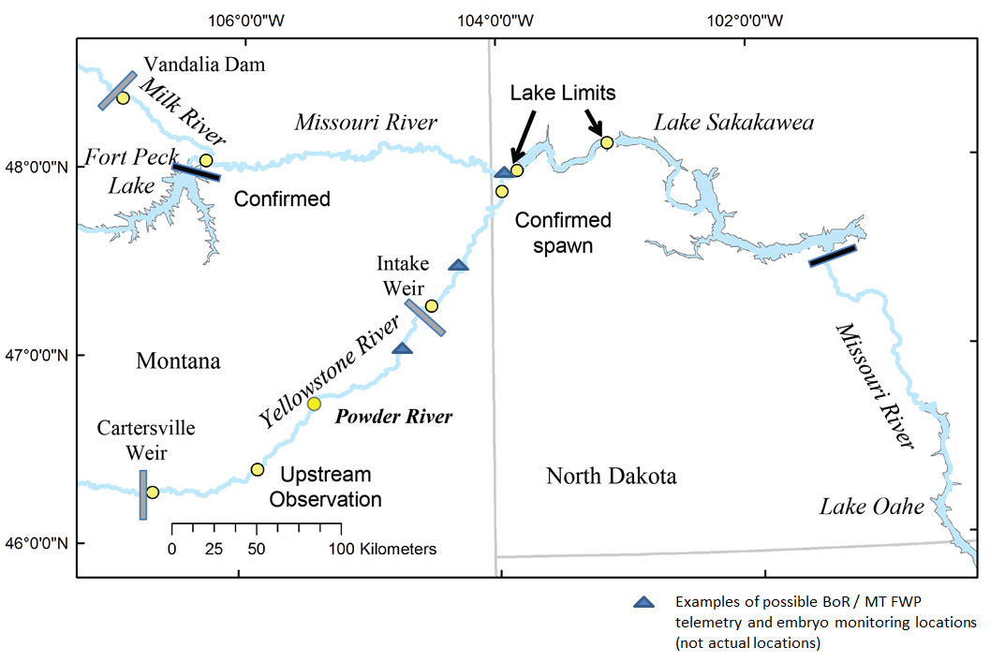

Figure 69. Locations of possible fixed telemetry locations (triangles) to monitor adult pallid sturgeon in the Yellowstone River.

Table 46 Summary of the monitoring questions for Intake and the decision relevance of different answers to these questions.

|  |  |  |  |  |
| --- | --- | --- | --- | --- |
|  |  | **Decision relevance of answers to questions** | | |
| **Question** | **Detailed questions** | **No [C:\Documents and Settings\davem\Local Settings\Temporary Internet Files\Content.IE5\H31TWIM3\MC900441321[1].pngC:\Documents and Settings\davem\Local Settings\Temporary Internet Files\Content.IE5\H31TWIM3\MC900441321[1].png or C:\Documents and Settings\davem\Local Settings\Temporary Internet Files\Content.IE5\H31TWIM3\MC900441321[1].png]** | **Inconclusive []** | **Yes [**C:\Documents and Settings\davem\Local Settings\Temporary Internet Files\Content.IE5\TVK1PAJ3\MC900441322[1].png **or** C:\Documents and Settings\davem\Local Settings\Temporary Internet Files\Content.IE5\TVK1PAJ3\MC900441322[1].pngC:\Documents and Settings\davem\Local Settings\Temporary Internet Files\Content.IE5\TVK1PAJ3\MC900441322[1].png**]** |
| Q1. Do motivated spawners and downstream adult migrants successfully move past Intake? | * Q1A: Are the target physical criteria (e.g., depth and velocity) for passage of pallid sturgeon being met? | Assess compliance with biological criteria (Q1B). If biological criteria are met, re-assess physical criteria, and assess upstream movement (Q2). If biological criteria are not being met, investigate deficiencies in passage provided (Q1C-E). | Collect more data. Re-assess design of compliance monitoring. (e.g., location, frequency, and/or timing of sampling). | Assess compliance with biological criteria (Q1B). If biological criteria being met, investigate distance of upstream movement (Q2). If biological criteria not being met, re-assess physical criteria. |
| * Q1B: Are the target biological criteria (e.g., number of motivated spawners moving upstream past Intake) being met? | If number of spawners moving upstream is not sufficient, investigate deficiencies of passage (Q1C-E). | Collect more data. Re-assess design of compliance monitoring (e.g., location, frequency, and/or timing of sampling). | If sufficient number of spawners move upstream, investigate distance of upstream movement (Q2). |
| * Q1C: Are fish able to approach and navigate the bypass? * Q1D: Is the speed of upstream / downstream movement of adults unimpeded? * Q1E: Does passage lead to injury, stress, or mortality of adult pallid sturgeon migrating downstream? | If problems are detected, modify the passage structure to improve number of adults moving upstream/downstream. Continue to monitor compliance with biological criteria (Q1B). | Collect more data. Re-assess monitoring of behavior and movement of adults through structure (e.g., location, frequency, and/or timing of sampling). | If no problems are detected, re-assess physical and biological criteria. Monitor distance of upstream movement (Q2). |
| Q2. How far upstream do motivated spawners migrate? | * Q2A: Do spawners migrate sufficiently far upstream to provide enough drift distance to support development of free embryos? | If migration distance is consistently insufficient, other Level 3 actions in the Upper River may be necessary. | Collect more data. Re-assess design of telemetry network (e.g., location, frequency, and/or timing of sampling). | If migration distance is sufficient, investigate success of aggregation and spawning (Q3). Consider other actions if necessary (i.e., passage at Cartersville). |
| Q3. Does successful aggregation and spawning occur? | * Q3A: Are spawning locations of suitable quality? | If spawning locations are unsuitable, investigate creation of spawning habitats. Continue to monitor upstream migration (Q2). | Collect more data. Re-assess monitoring of spawning locations (e.g., location, frequency, and/or timing of sampling). | If spawning locations are of suitable quality, investigate aggregations and spawning success (Q3B-C). |
| * Q3B: Do spawners aggregate in sufficient numbers to initiate spawning? * Q3C: Is spawning successful? | If aggregations and/or spawning are unsuccessful, consider ways to increase success (e.g., increase numbers as hatchery fish mature). Other Level 3 actions in the Upper River may be necessary. | Collect more data. Re-assess design of spawning occurrence (e.g., location, frequency, and/or timing of sampling). | If aggregations and spawning is successful, investigate downstream movement past Intake (Q4) and whether natural recruitment occurs (Q5). |
| Q4. Do free embryos, larvae, and young-of-year successfully move downstream past Intake? | * Q4A: Can embryos, larval, and young-of-year sturgeon move downstream without impacts on survival (i.e., due to impingement and entrainment)? | If Intake has impacts on survival of juveniles, investigate source of mortality (Q4B). | Collect more data. Re-assess juvenile monitoring of downstream passage at Intake (e.g., location, frequency, and/or timing of sampling). | If juvenile survival is unaffected by downstream passage through Intake, investigate whether natural recruitment occurs (Q5). |
| * Q4B: Are sources of impact on survival of embryos due to physical conditions / structures at Intake (i.e., over dam, through side channel, entrained in canal)? | If impacts are not directly related to Intake, investigate other potential sources of mortality (e.g., predators). | Collect more data. Re-assess juvenile monitoring of downstream passage at Intake (e.g., location, frequency, and/or timing of sampling). | Modify structures at Intake to improve downstream passage of juveniles. Re-assess physical criteria for downstream passage at Intake. Continue to monitor impacts on downstream passage (Q4A). |
| Q5. Is recruitment successful and sufficient to meet population targets? | * Q5A: Does successful spawning result in recruitment? | Investigate sources of potential limitation in recruitment (e.g., distance upstream, passage at Cartersville, number of spawners, quality of spawning habitats, passage efficiency at Intake). Take action to address potential limitations. | Collect more data. Re-assess design of juvenile monitoring (e.g., location, frequency, and/or timing of sampling). | Test genetics of embryos to parentage of upstream spawners. Apply population model. Assess whether natural recruitment is sufficient to meet population targets (Q5B). |
| * Q5B: Is the level of recruitment sufficient to meet population targets (95% probability of persistence over a 50-year period)? | Investigate opportunities to enhance natural recruitment. Take action. Continue to monitor (Q1-5). | Collect more data. Re-assess design of juvenile monitoring and/or population model (e.g., location, frequency, and/or timing of sampling). | Maintain beneficial actions to ensure success in achieving recovery goals. Continue to monitor (Q1-5). |

##### Level 3 Contingent Actions

### Details on Level 3 Actions (and associated Level 2 components) for Lower Missouri River

#### Level 2 Studies - Population Augmentation

#### Interception and Rearing Complexes (IRCs)

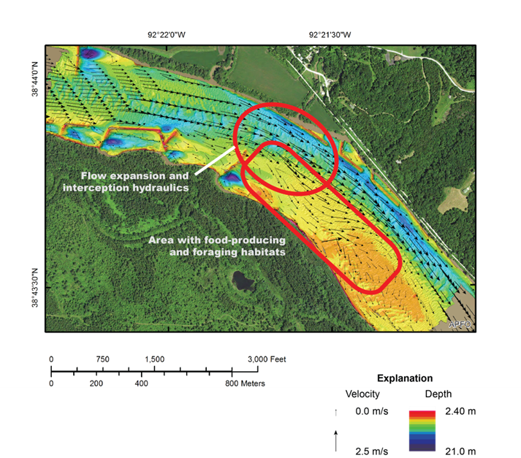

Figure 72 Concept of an interception-rearing complex near river mile 162. Flow expansion is shown by modeled current velocity and direction (arrows) angled away from the channel and towards the right descending bank.

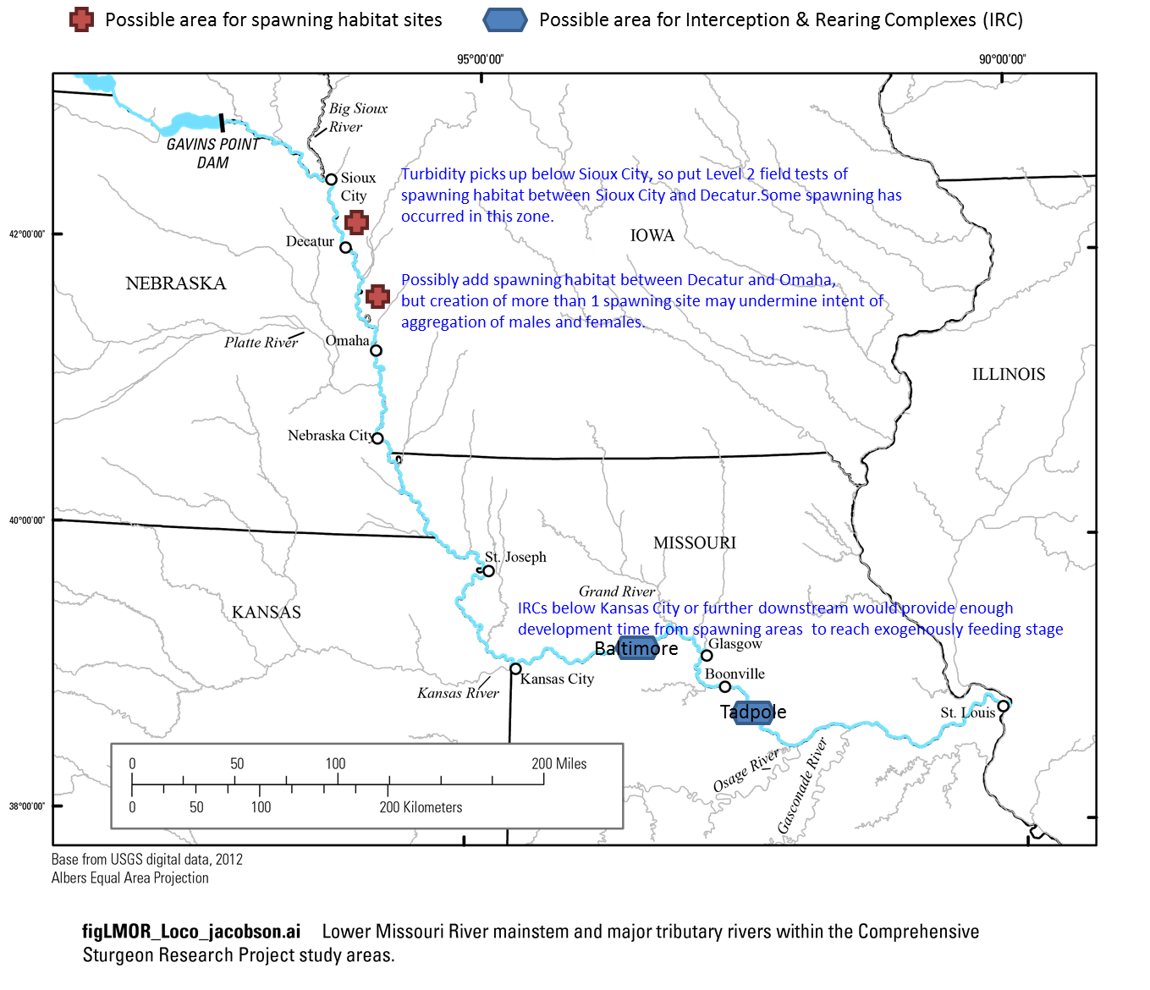

Figure 74. Possible locations of new spawning habitats (red symbols), and Interception and Rearing Complexes (IRCs; blue symbols). The general rationale for these general locations is shown on the map in blue text, with further details in the text of this section.

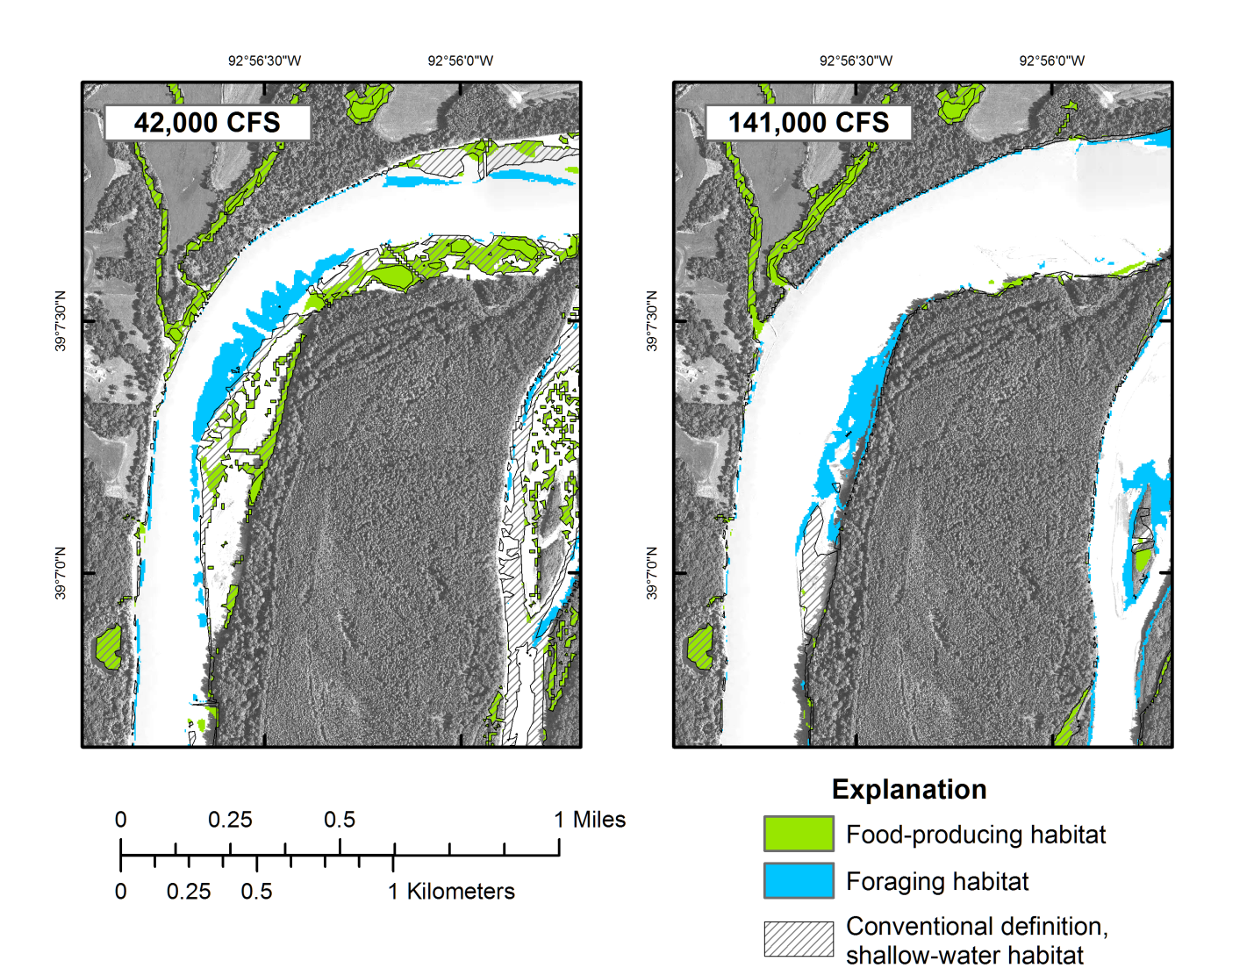

Figure 75 Maps of food-producing and foraging habitats modeled with a hydrodynamic model, river mile 219, Lower Missouri River, at two discharges. Food-producing and foraging habitats are two components of IRCs; conventionally defined shallow-water habitats are shown for comparison. Left side: Habitats at discharge of 42,000 cubic feet per second (cfs). Right side: Habitats at discharge of 141,000 cfs.

#### Interception and Rearing Complexes (IRCs) via Modification of Existing Shallow Water Habitat (SWH) Projects

Table 47. Number of SWH construction actions by USACE river segment (11 is Ponca to Big Sioux River; 12 is Big Sioux River to Platte River; 13 is Platte River to Kansas River; 14 is Kansas River to Osage River; 15 is Osage River to the Mississippi River).

|  |  |  |  |  |  |  |  |  |  |
| --- | --- | --- | --- | --- | --- | --- | --- | --- | --- |
| **River Segment** | **Main Channel Modifications** | | | | | | **Off-Channel Projects** | | |
| **Dike Notching1** | **Major Modification Actions2** | **Dike Extension** | **Dike Lowering** | **Revetment Chute** | **Channel Widening** | **Side-Channel Chute** | | **Backwater** |
| Segment 11 | -- | -- | -- | -- | -- | -- | -- | | -- |
| Segment 12 | 95 | 123 | -- | -- | -- | 3 | 12 | | 9 |
| Segment 13 | 487 | 231 | -- | 27 | 10 | -- | 13 | | 5 |
| Segment 14 | 788 | -- | 16 | 36 | 7 | -- | 13 | | -- |
| Segment 15 | 327 | -- | 20 | -- | 3 | -- | 1 | | -- |
| **Total # of Actions** | **1,697** | **354** | **36** | **63** | **20** | **3** | **39** | | **14** |
|  | | |  |  | | | |  | |
| 1actions include dike notching, type B notching, rootless dikes, revetment notches, and bank notches. | | | | | | | | | |
| 2actions include chevron construction and other similar actions | | | | | | | | | |

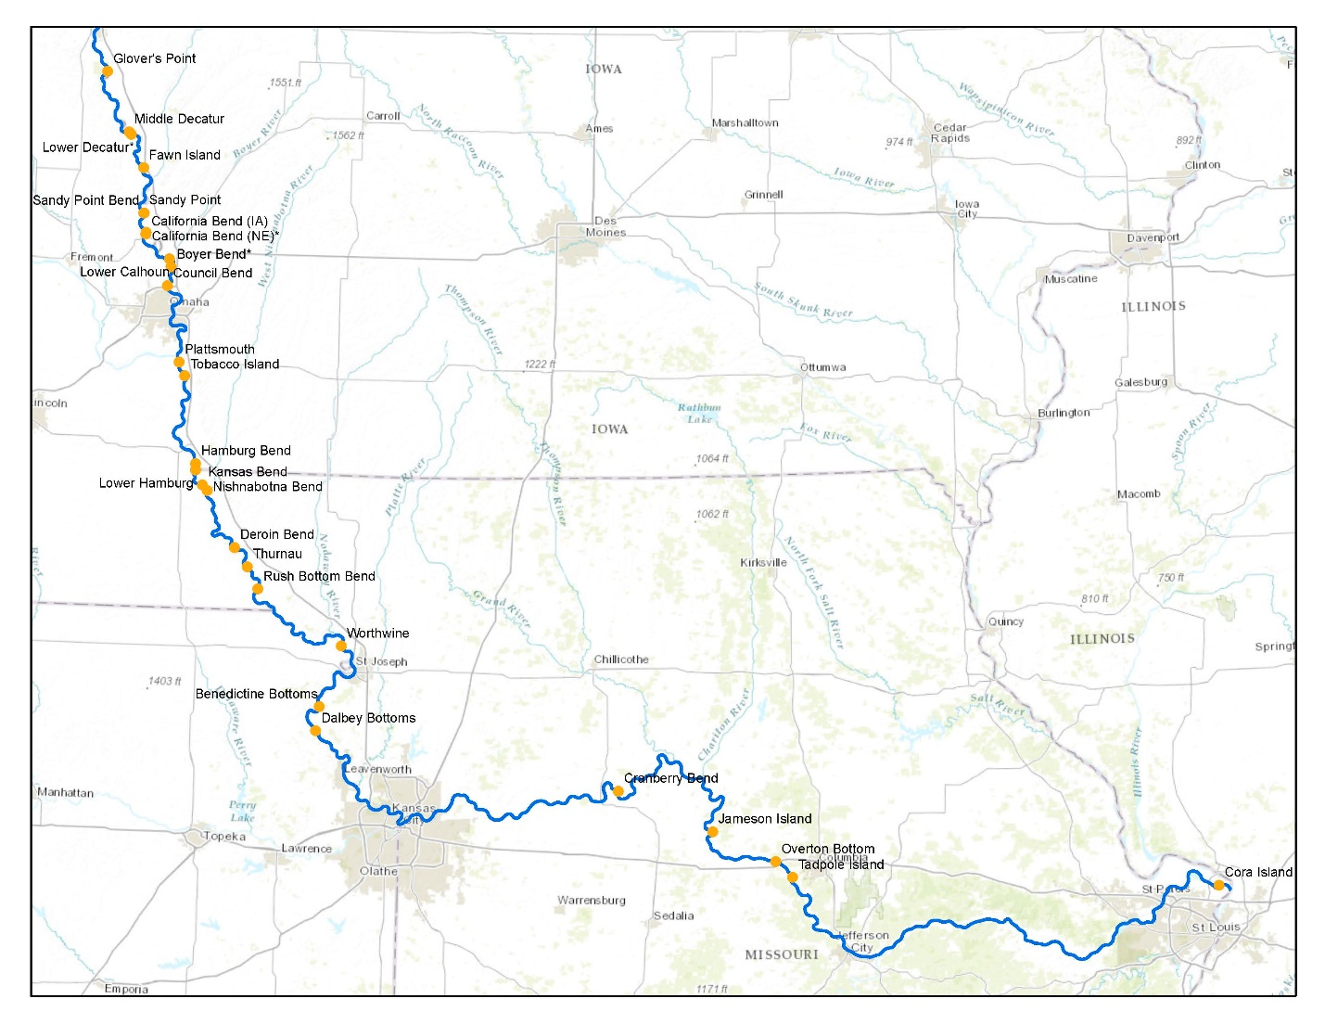

Figure 76. Existing chute locations that may be available for modification to provide IRC habitats.

#### Spawning Habitat

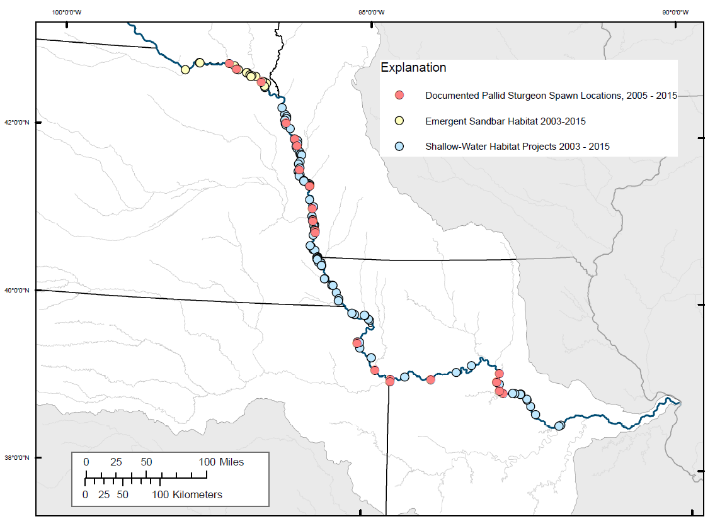

Figure 77. Distribution of known spawning sites in the lower Missouri River.

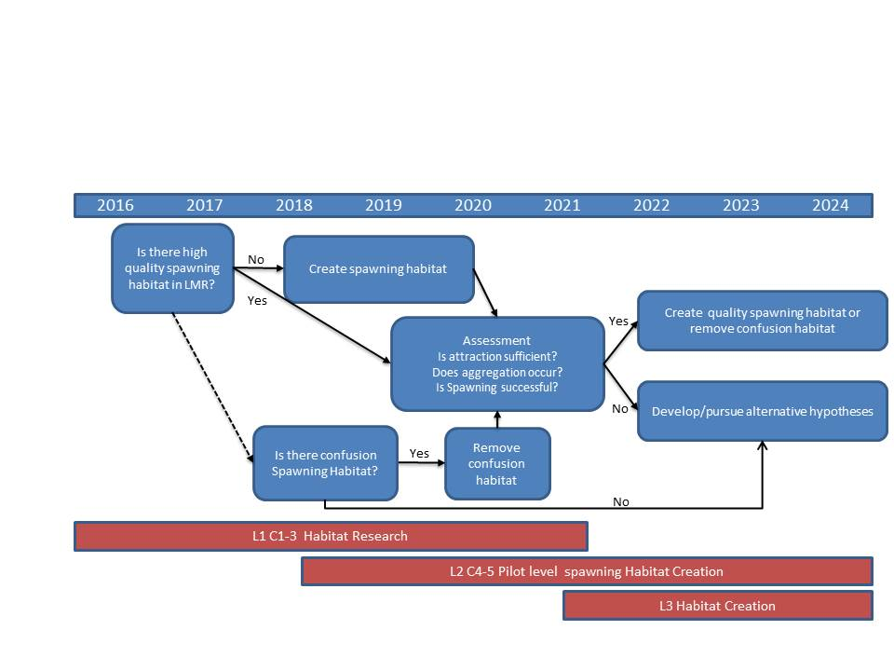

Figure 78. Decision tree for spawning habitat. Source: USFWS and USACOE (2015)

#### Spawning Cue Flows

Table 48 Evidentiary Framework for Flow Observations. This decision aid is intended to determine if sufficient spawning cue flow events occur during the first nine years of implementation post ROD, and to determine if an explicitly managed spawning cue flow should be implemented after the ninth year to test flow hypotheses.

|  |  |  |  |  |
| --- | --- | --- | --- | --- |
| **Question** | | **Potential Metrics and Lines of Evidence Based on Observations over 9 years** | | |
| **No [C:\Documents and Settings\davem\Local Settings\Temporary Internet Files\Content.IE5\H31TWIM3\MC900441321[1].pngC:\Documents and Settings\davem\Local Settings\Temporary Internet Files\Content.IE5\H31TWIM3\MC900441321[1].png or C:\Documents and Settings\davem\Local Settings\Temporary Internet Files\Content.IE5\H31TWIM3\MC900441321[1].png]** | **Inconclusive []** | **Yes [**C:\Documents and Settings\davem\Local Settings\Temporary Internet Files\Content.IE5\TVK1PAJ3\MC900441322[1].png **or** C:\Documents and Settings\davem\Local Settings\Temporary Internet Files\Content.IE5\TVK1PAJ3\MC900441322[1].pngC:\Documents and Settings\davem\Local Settings\Temporary Internet Files\Content.IE5\TVK1PAJ3\MC900441322[1].png**]** |
| Q1. Are there attributes of river flow that are strongly correlated with upstream movement of male and female pallid sturgeon of reproductive age? | | Sufficient contrast of flows has occurred over first 9 years to answer this question, and movements of pallid sturgeon have been well monitored, but no significant correlations are apparent between flow and movement. **Flows aren’t associated with movement.** | Insufficient contrast of flows has occurred over first 9 years to be able to rigorously answer this question. **Effects of flows unclear.** | Sufficient contrast of flows has occurred over first 9 years to answer this question, movements of pallid sturgeon have been well monitored, and significant correlations are apparent between flow and movement, at flow magnitudes that could be released by managers. **Flows are associated with movement.** |
| Q2. Are there attributes of river flow that are strongly correlated with immediately subsequent spawning aggregations of telemetered male and female pallid sturgeon of reproductive age? | | Wide contrast of flows has occurred over first 9 years (below and above potential spawning flows) and movements of telemetered pallid sturgeon have been well monitored, but no significant correlations are apparent between flow and spawning aggregations. **Flows aren’t associated with aggregation.** | Insufficient contrast of flows has occurred over first 9 years to be able to rigorously answer this question. **Effects of flows unclear.** | Wide contrast of flows has occurred over first 9 years (below and above potential spawning flows), movements of telemetered pallid sturgeon have been well monitored, and significant correlations are apparent between flow and spawning aggregations, at flow magnitudes that could be released by managers. **Flows are associated with aggregation.** |
| Q3. If the answers to Q1 and Q2 were “yes””, do upstream movements and spawning aggregations lead to documented successful spawning? | | n.a. [Answers to Q1 and Q2 were “No”, so Q3 does not apply. If successful spawning did occur, it was not due to flow-triggered movement and aggregation] | n.a. [Answers to Q1 and Q2 were “Inconclusive”, so Q3 does not apply.] | Successful spawning observed at spawning sites (gravid females released eggs in the presence of males), following flow-associated upstream movement and spawning aggregations. **Strong evidence that flows support spawning.** |
| Q4. If successful spawning occurs (and answers to Q1, Q2 and Q3 are “yes”), are viable embryos found downstream of the spawning site? | | n.a. [Answers to Q1 and Q2 was “No”, so Q4 does not apply. If successful spawning did occur, it was not due to flow-associated movement and aggregation] | n.a. [Answers to Q1 and Q2 were “Inconclusive”, so Q4 does not apply.] | Viable embryos found downstream of successful spawning events that are genetically related to the males and females observed to be spawning. **Very strong evidence that flows support spawning.** |
| Q5. Do successful spawning events occur sufficiently frequently under current water management rules to prevent jeopardy and support recovery? | | No. Successful spawning does not occur frequently enough under current water management rules to prevent jeopardy and support recovery. | Inconclusive (e.g., not enough tagged fish to estimate total spawning success) | Yes. Successful spawning occurs frequently enough under current water management rules to prevent jeopardy and support recovery. |
| **Conclusions regarding need for spawning flows after Year 9** | No to Q1-Q2: Do not implement spawning flows at Level 2.  Inconclusive to Q1-Q2: Implement spawning flows on a trial basis (Level 2) to get enough contrast and answer Q1-Q4.  Yes to Q1-Q2 and No to Q5: Possibly implement spawning flows on a trial basis (Level 2), and do research to understand what else is limiting spawning success (e.g., substrate, predation).  Yes to Q1-Q2 and Yes to Q5: Rely on natural flows from tributaries to trigger movement and aggregation, and do research to understand what else is limiting spawning success.  Yes to Q1-Q4, No to Q5: Possibly implement spawning flows on a trial basis (Level 2), and if successful, continue to do so once every 3 years (Level 3). Continue to monitor movement, aggregation, spawning.  Yes to Q1-Q5: Rely on natural flows from tributaries to trigger movement, aggregation, and successful spawning. Continue to monitor movement, aggregation, spawning. | | | |

Table 49. Proposed characteristics of Level 3 spawning cue flows.

|  |
| --- |
| The first pulse from Gavins Point would conform to the following guidelines:   * Rise begins on first day after flow to target navigation flows are achieved. * Peak release from Gavins Point is equal to double the flow to target level release the first day of navigation flow to target levels are achieved from Gavins Point * Increase to peak by 2,200 cfs per day * Maintain peak for 2 days * Reduce pulse by 1,700 cfs/day until releases are back to base flow to target levels   The second pulse is cued by water temperature (**16-18 degrees**) at Sioux City Iowa as follows.   * Checks to implement release increases   + > 40.0 MAF in System Storage on March 15 storage check   + Steady release has been set and implemented for 3 days * Releases from Gavins Point   + Rise begins on May 18 or later based upon water temperature and implementation of steady release for at least 3 days   + Increase to peak by 2,200 cfs per day   + Peak release from Gavins Point is equal to twice the steady release from Gavins Point   + Maintain peak for 2 days   + Reduce pulse by 1,900 cfs per day until the steady release flows are reached * Flood targets will be the full service flood targets increased by the steady release level   + If the steady release is 31 kcfs and the full service flood targets are 41 kcfs, 47 kcfs*,* and 71 kcfs at Omaha, Nebraska City, and Kansas City, respectively, the new flood targets will be 72 kcfs at Omaha (31 + 41), 78 kcfs at Nebraska City (31 + 47), and 102 kcfs at Kansas City (31 + 71). |

#### Potential Effects of bird actions on pallid sturgeon

## Implement

### Implementation Plan

Figure 82 and Figure 82 summarize the current implementation schedules for the actions described above in sections 4.2.5 and 4.2.6, and the associated components at Levels 1, 2 and 3 (in the order of presentation of each of these actions). These schedules build on the plans presented by the USFWS and USACE (2015), and have been updated to reflect both the preferred alternative and current USFWS priorities and timelines, as well as joint USFWS and USACOE work on prioritization of Level 1 and Level 2 activities, described in Appendix F.

Figure 83 and Figure 84 provide the currently proposed schedule for all Level 1 and Level 2 components in the Upper and Lower Missouri River (respectively), for the first five years after the ROD, based on the prioritization described in Appendix F. The longer term schedule for Level 1 and Level 2 activities is presented in Appendix F. The schedule will require a well-funded and focused surge in research activity conducted by multiple research teams that work in close coordination (see Appendix F).

As noted in section 4.2.1 summarizing the Lower Missouri River Pallid Sturgeon Framework (USFWS and USACE 2015), the timeframe for implementation may be adjusted as knowledge is gained from Level 1, 2 and 3 actions, hypotheses are tested, and the likelihood of biological benefits is better understood. Budget allocations may also affect the timing of particular activities. The rationale for any adjustments in schedule should be well documented.



Figure 81. Current schedule for implementation of actions in the Upper Missouri River, revised from USFWS and USACE (2015) to reflect the preferred alternative and current USFWS priorities and timelines, and described in sections 4.2.5 of this report. Arrows represent flexibility in the timing of implementation. This figure is an illustration of the intended implementation schedule. There may be further adjustments in the schedule. In-river actions at Level 2 and Level 3 are shown in bolded blue text.



Figure 82. Current schedule for implementation of actions in the Lower Missouri River, revised from USFWS and USACE (2015) to reflect the preferred alternative and current USFWS priorities and timelines, and described in section 4.2.6 of this report. Arrows represent flexibility in the timing of implementation. This figure is an illustration of the intended implementation schedule. There may be further adjustments in the schedule. In-river actions at Level 2 and Level 3 are shown in bolded blue text.

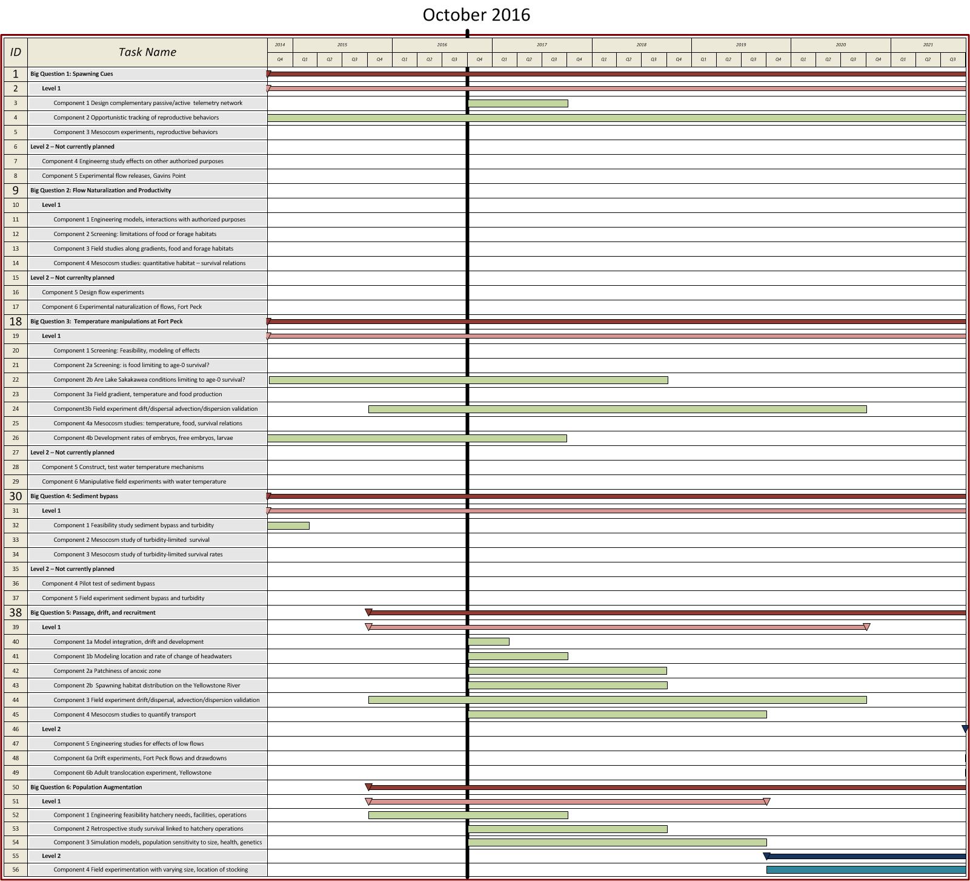

Figure 83. Proposed schedule for all science and AM components (Levels 1 and 2) in the Upper Missouri River during the first 5 years post ROD.

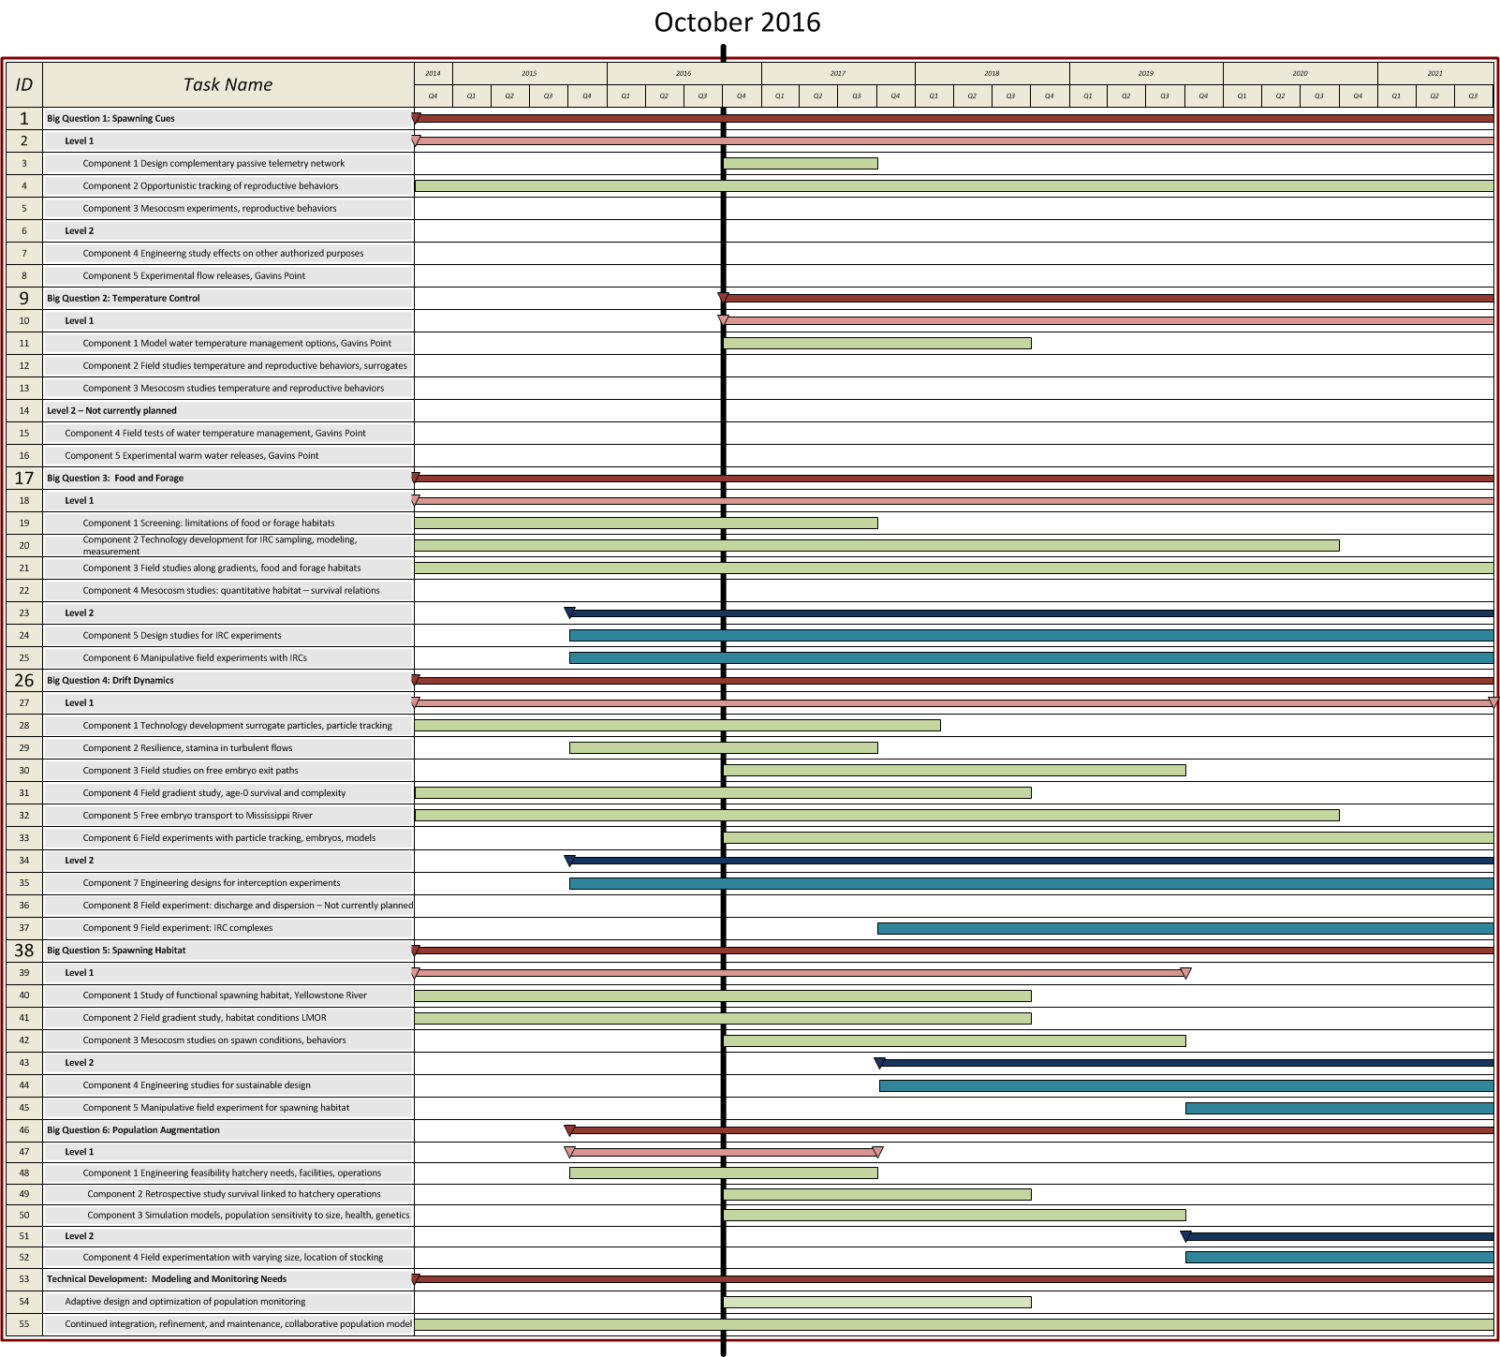

Figure 84.Proposed schedule for all science and AM components (Levels 1 and 2) in the Lower Missouri River, during the first 5 years post ROD.

## Monitor

There are 3 types of monitoring that need to be conducted as the AM Plan proceeds:

* Implementation Monitoring – did the action get successfully completed as intended?
* Process / Action Effectiveness Monitoring – is there an ecological response that will increase survival or appropriately inform the next Level of implementation towards achieving increased survival?
* Population Monitoring – is the population growing, attaining the right size?

<< info removed >>

Table 51. Summary of metrics to be used for implementation, process / action effectiveness and population monitoring for each Level 2 and Level 3 action described in sections 4.2.5 and 4.2.6. Hypotheses listed in first column (e.g., H8, H9) are those most relevant to the action, as discussed in section 4.2. The section listed in the first column provides a more detailed description of metrics associated with a given action; other metrics are listed in Appendix K.

| **Level 2 / 3 Action** | **Implementation monitoring** | **Process monitoring** | **Population monitoring** |
| --- | --- | --- | --- |
| Augmentation  [H8, H9] [H20, H21]  Metrics: section  4.2.5.1.5 | -meeting stocking targets by age, hatchery and release location  -meeting health criteria in hatchery  -fulfilling experimental design of Level 2 management experiments | - Number, size, age, location, habitat and origin of released and captured pallid sturgeon  -fish condition, genetics, disease levels  -density of hatchery-origin free embryos and larvae found in preferred rearing habitats | -estimated survival probabilities of hatchery fish to age-1,2 and 3, by stocked size, age, hatchery of origin, release location  -modelled long term change in population based on survival probabilities of hatchery origin fish (e.g., probability of quasi extinction, population growth rates)  - effective population size |
| Intake Dam  [H7]  Metrics: section  4.2.5.2.5 | -safe upstream and downstream passage of adults  -safe downstream passage of embryos, free embryos and larvae | -density of free embryos and larvae found in preferred rearing habitats (and not headed for anoxic zones of Lake Sakakawea)  -estimated improvement in spawning and recruitment from passage around Intake Dam (same metrics for monitoring spawning as for spawning cue flows) | -modelled long term change in population based on estimated proportional increase in successful spawning due to passage around Intake Dam (if such an increase occurs) |
| IRC Habitat  [H17, H18, H19]  Metrics:  sections  4.2.6.3.5 and  4.2.6.4.5 | -“effective acreage” (acre-days of available IRC habitat/year) | - habitat metrics based on measures of depths, velocities, substrate, habitat complexity  - trends in % SWH area with suitable habitat after refurbishment to IRCs  -CPUE and Pr (apparent presence) at meso-habitat and project level;  - production of food/area  -fish condition (% empty/full stomachs; genetics; lipid content; length frequency distribution of age-0 fish) and bioenergetics modeling | -survival of hatchery-reared first-feeding pallid sturgeon larvae in IRCs, refurbished SWH, thalweg, and to age 1  -population size structure analysis (length-frequency distributions of age-1+ fish) |
| Spawning Habitat  [H16]  Metrics:  section  4.2.6.5.5 | -# and area of spawning sites created with suitable characteristics (depth, velocity, substrate, and derivative hydraulic variables) | - confirmation of site quality  -telemetry data showing relative selection of created spawning sites vs. control sites  -attraction/specificity of adults to different spawning substrates; site confirmation that eggs are not buried  -confirmation of spawning (see evidentiary framework on spawning cue flows - Table 48) | -modelled long term change in population based on estimated proportional increase in successful spawning due to creation of high quality spawning habitat (if such an increase occurs)  - field monitoring of recruitment to age-1,2,3 |
| Spawning Cue Flows  [H11]  Metrics:  section  4.2.6.5.5 | -flow monitoring to check whether spawning cue flow had expected timing, magnitude, and longitudinal spatial distribution | -movement and aggregation of spawning males and females in response to spawning cue flow  -multi-receiver, 3D telemetry and acoustic video to confirm egg release events  - male: female ratios in spawning aggregations (if sufficient # males tagged)  -confirmation of female spawning through captured downstream eggs and embryos, and recapture of spawned females | -mesocosm and field-inferred benefit of achieved pulse  -modelled long term change in population based on estimated proportional increase in successful spawning due to spawning cue (if such an increase occurs)  - field monitoring of recruitment to age-1,2,3 (delayed metric reflecting the cumulative effect of all actions, other stressors and natural variability) |

## Evaluate

### Evaluation Methods

Table 52 summarizes the methods used to evaluate the effectiveness of various actions, applying the metrics that are summarized above in Table 41, and listed in Appendix K. Each action is broken down into a series of key questions, andthe evaluation methods used to answer each question. The first column of Table 47 includes hyperlinks to the parts of sections 4.2.5 and 4.2.6 describe the details of the experimental designs and evaluation methods for each action, and its associated key questions.

Table 52. Summary of methods for evaluating the effectiveness of Level 3 actions. Some of these actions also have Level 2 management experiments. Hypotheses listed in first column (e.g., H8, H9) are those most relevant to the action, as discussed in section 4.2, and listed in Table 43 and Table 44. [Upper]=Upper Missouri River; [Lower] =Lower Missouri River. L2=Level 2. L3=Level 3. The sections listed in the first column provide more details on the experimental design for each action; Appendix K provides a list of metrics for each management action, as well as status and trend monitoring.

| Action | Question [Level, Location] | Methods of evaluating action effectiveness |
| --- | --- | --- |
| Augmentation  [H8, H9] [H20, H21]  Experimental design:  section  4.2.5.1.6 | Is the region releasing the optimal sizes of hatchery fish (i.e., fingerlings or yearlings)? [L2, Lower] | Use a staircase design over multiple years to compare the survival probabilities of fish stocked as fingerlings vs. yearlings, while accounting for the hatchery of origin and other factors affecting survival rates. See list of metrics in section 4.4 |
| Is the region releasing fish from the optimal locations? [L2, Upper and Lower][5] | Compare various metrics (e.g., recapture probabilities, recapture location, condition, survival probabilities) of different groups of marked fish that are released from different locations (e.g., upstream vs. downstream of Intake Dam; Missouri vs. Yellowstone River), and then recaptured at multiple locations and times. |
| Is augmentation meeting target survival rates, ensuring a 95% probability of persistence over a 50-year period and supporting positive trends in populations? [L3, Upper & Lower]  Is there a self-sustaining population in excess of 5000 adult fish in each management unit? | Apply the augmentation strategies developed in Level 2 studies, and compare 3-year running averages of various metrics (see augmentation row in Table 9, section 4.4) to established targets, (as informed by Level 1 and Level 2 studies, particularly population modeling studies). |
| Intake Dam  [H7]  Experimental design:  sections  4.2.5.2.6  4.2.6.2.4 | Do adult pallid sturgeon migrate upstream past Intake Dam, migrate to spawning sites and aggregate there? [L3, Upper] | Tracking of telemetered adult fish using USGS methods. |
| Do adults of reproductive age spawn successfully in the Yellowstone River above Intake Dam? [L3, Upper] | Post-spawn monitoring of free embryos, larvae, and juveniles (with genotypes traced to parents), at various locations (e.g., downstream of spawning site, downstream of Intake Diversion Dam) |
| Are some of the juveniles (age 3+) collected in the Yellowstone River the progeny of tagged adult fish that migrated upstream of Intake Diversion Dam? [L3, Upper] | Monitoring of age 3+ juveniles in Yellowstone River and assessment of genetic parentage |
| What are the attributes of selected spawning sites (useful for design of spawning sites in L. Missouri)? [L2/ L3, Upper] | Document site characteristics of spawning locations (e.g., substrate, velocity, water temperature, suspended sediment, cross-section profile) |
| Do free embryos avoid dispersal into Lake Sakakawea? [L3, Upper] | Apply refined advection/dispersion models. |
| Does spawning in Yellowstone River above Intake Dam improve the trajectory of the Upper Missouri River population of pallid sturgeon, and suggest that the population has a 95% probability of persistence over a 50-year period? [L3, Upper] | Apply collaborative population model using estimates from above studies for spawning locations above and below Intake Dam (e.g., frequency of spawning, proportion of successful spawning, indices of relative abundance and survival) to assess overall effect on population. |
| Interception and Rearing Complexes (IRCs)  [H17, H18, H19]  Experimental design:  sections  4.2.6.3.4  4.2.6.4.4 | Do free embryos and exogenously feeding larvae leave the thalweg and enter IRCs? [L3, Lower]  Is there sufficient food in IRCs for exogenously feeding larvae to grow better and maintain a healthier condition than reference areas and times?[6] [L3, Lower]  Do age-0 fish that occupy IRCs survive better than age-0 fish in reference areas and times? [L3, Lower]  What’s the population-level effect of improved survival of age-0 fish in IRCs? [L3, Lower]  Is food limiting outside of IRC habitats[L3, Lower] | Predicted fate of free embryos from advection/ dispersion models. Testing of these predictions with field monitoring (see below).  Staircase design comparisons of IRC habitat sites with reference areas and times, using the metrics listed in Table 9, section 4.4 (e.g., CPUE, probability of apparent presence, food production/area, condition, growth and survival of age-0 fish), and applying covariates to help explain year to year variation (e.g., index of upstream spawning success).  Population model projections of the consequences of improved age-0 survival rates. |
| Spawning Habitat  [H16]  Experimental design:  section  4.2.6.5.6 | To what extent does successful spawning occur now? [redesigned PSPAP and other monitoring]  Has suitable spawning habitat been created and maintained? [L2/L3, Lower]  Are created spawning habitats preferred over other areas by pallid sturgeon in reproductive condition? [L2/L3, Lower]  Does successful spawning occur in the created spawning habitat? [L2/L3, Lower]  Would creation of more high-quality spawning habitat at Levels 3 and 4 have a significant benefit to the population? [L2/L3, Lower] | Compare metrics listed in Table 51 for the created spawning area(s) (see Figure 77 for possible areas) vs. reference areas (other outside bends used for spawning – see Figure 78)  Population model projections of the consequences of creating more spawning habitat |
| Spawning Cue Flows  [H11]  Experimental design:  Section  4.2.6.6.6 | Do spawning cue flows lead to greater aggregations of pallid sturgeon in reproductive condition? [L2/L3, Lower]  Do spawning cue flows lead to higher rates of successful spawning? [L2/L3, Lower]  Would creation of more spawning cue flows at Levels 3 and 4 have a significant benefit to the population? [L2/L3, Lower] | Assemble evidence for and against benefits of spawning cue flows from Level 2 mesocosm and gradient studies.  To the degree possible while accounting for confounding effects, compare metrics listed in Table 9 for years and locations with a strong spawning cue flow vs. years and locations without a spawning cue flow.  Population modeling of the consequences of creating more spawning cue flows. |

## Decide

<< material removed >>

Table 53 summarizes the criteria for deciding whether to move from a Level 2 action to a Level 3 action, and whether to move from Level 3 to Level 4 (i.e., decision categories B and C). These criteria are based on the ‘Decision criteria’ parts of section 4.2, and the decision-relevant questions from Table 52 (most of the questions listed above). The colored columns to the right of Table 53 show five possible answers to each question, drawn from the approach used in the Platte River Recovery Implementation Program (PPRIP 2014), and similar to other approaches used for weight of evidence syntheses (e.g., Peterman et al. 2010, Marmorek et al. 2011). Details on decision criteria are provided in the sections listed in the first column of Table 53. Chapter 2 of this AMP describes the governance process for the Missouri River Management Plan.

Table 53. Summary of decision criteria to be applied to the currently proposed set of Level 3 actions. Hypotheses listed in first column are those most relevant to the action, as discussed in section 4.2. The sections listed in the first column provide more details on the decision criteria for each action. Appendix K provides a list of metrics for each management action, as well as status and trend monitoring.

| **Level 2 / 3 Action**  **[Hypothesis]** | **Decision Criteria / Questions** | **Answers** | | | | |
| --- | --- | --- | --- | --- | --- | --- |
| **Clearly NO.**  **C:\Documents and Settings\davem\Local Settings\Temporary Internet Files\Content.IE5\H31TWIM3\MC900441321[1].pngC:\Documents and Settings\davem\Local Settings\Temporary Internet Files\Content.IE5\H31TWIM3\MC900441321[1].png** | **Likely NO.**  **C:\Documents and Settings\davem\Local Settings\Temporary Internet Files\Content.IE5\H31TWIM3\MC900441321[1].png** | **Incon-clusive** | **Likely YES.**  C:\Documents and Settings\davem\Local Settings\Temporary Internet Files\Content.IE5\TVK1PAJ3\MC900441322[1].png | **Clearly YES.**  C:\Documents and Settings\davem\Local Settings\Temporary Internet Files\Content.IE5\TVK1PAJ3\MC900441322[1].pngC:\Documents and Settings\davem\Local Settings\Temporary Internet Files\Content.IE5\TVK1PAJ3\MC900441322[1].png |
| Augmentation  [H8, H9] [H20, H21]  Decision criteria: sections  4.2.5.1.7 and  4.2.6.2.5 | Is augmentation meeting target survival rates, ensuring a 95% probability of persistence over a 50-year period and supporting positive trends in upper and lower river populations? [L3, Upper and Lower]  Is there a self-sustaining population in excess of 5000 fish in each management unit? |  |  |  |  |  |
| Intake Dam  [H7]  Decision criteria: section  4.2.5.2.7 | Do adult pallid sturgeon migrate upstream past Intake Dam, migrate to spawning sites and aggregate there? [L3, Upper] |  |  |  |  |  |
| Do adults of reproductive age spawn successfully in the Yellowstone River above Intake Dam? [L3, Upper] |  |  |  |  |  |
| Are some of the juveniles (age 3+) collected in the Yellowstone River the progeny of tagged adult fish that migrated upstream of Intake Diversion Dam? [L3, Upper] |  |  |  |  |  |
| Do free embryos avoid dispersal into Lake Sakakawea? [L3, Upper] |  |  |  |  |  |
| Does spawning in Yellowstone River above Intake Dam improve the trajectory of the Upper Missouri River population of pallid sturgeon, and suggest that the population has a 95% probability of persistence over a 50-year period? [L3, Upper] |  |  |  |  |  |
| Interception and Rearing Complexes (IRCs)  [H17, H18, H19]  Decision criteria: sections  4.2.6.3.6 and  4.2.6.4.6 | Do free embryos and exogenously feeding larvae leave the thalweg and enter IRCs? [L3, Lower] |  |  |  |  |  |
| Is there sufficient food in IRCs for exogenously feeding larvae to grow better and maintain a healthier condition than in reference areas and times? [L3, Lower] |  |  |  |  |  |
| Do age-0 fish that occupy IRCs have a higher survival probability than age-0 fish in reference areas and times? [L3, Lower] |  |  |  |  |  |
| What’s the population-level effect of improved survival of age-0 fish in IRCs? [L3, Lower] |  |  |  |  |  |
| Spawning Habitat  [H16]  Decision criteria: section  4.2.6.5.7 | Has suitable spawning habitat been created and maintained? [L2/L3, Lower] |  |  |  |  |  |
| Are created spawning habitats preferred over other areas by pallid sturgeon in reproductive condition? [L2/L3, Lower] |  |  |  |  |  |
| Does successful spawning occur in the created spawning habitats? [L2/L3, Lower] |  |  |  |  |  |
| Would creation of more high-quality spawning habitat at Level 4 have a significant benefit to the population? [L2/L3, Lower] |  |  |  |  |  |
| Spawning Cue Flows  [H11]  Decision criteria: section  4.2.6.6.7 | Do spawning cue flows lead to greater aggregations of pallid sturgeon in reproductive condition? [L2/L3, Lower] |  |  |  |  |  |
| Do spawning cue flows lead to higher rates of successful spawning? [L2/L3, Lower] |  |  |  |  |  |
| Would creation of more spawning cue flows at Levels 3 and 4 have a significant benefit to the population? [L2/L3, Lower] |  |  |  |  |  |

1. Lower: 317 bends, in river km, mean=4, min=0.2, max=19; in river mi mean=2.5, min=0.1, max=11.8;

   Upper: 157 bends, in river km, mean=2.3, min=0.6, max=8; in river mi mean=1.4, min=0.4, max=5;
2. Detailed alternative formulation and decision rationale will be included with the release of the Draft EIS in December 2016
3. For further information please see the Final EIS and ROD for the Lower Yellowstone Intake Diversion Dam Fish Passage Project (USBOR and USACE 2016a, 2016b)
4. For further information please see the Final EIS and ROD for the Lower Yellowstone Intake Diversion Dam Fish Passage Project (USBOR and USACE 2016a, 2016b)
5. This and the above question are example questions; the critical uncertainties to be resolved will emerge from the Stocking and Augmentation Plan under development by the Recovery Team.
6. For this to be true, food would need to be a limiting factor that was made less limiting by the creation of IRCs.